MODULE II
RELATIONAL MODEL
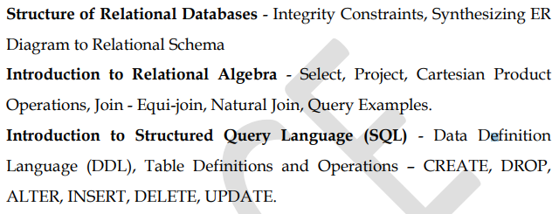
Relational data model
The relational data model was first introduced by Ted Codd of IBM Research in 1970 in a classic paper (Codd 1970). The model uses the concept of a mathematical relation—which looks somewhat like a table of values—as its basic building block, and has its theoretical basis in set theory and first-order predicate logic.
The first commercial implementations of the relational model became available in the early 1980s, such as the SQL/DS system on the MVS operating system by IBM and the Oracle DBMS.
• Represent database as a collection of relations
• Relation is a table which has values and rows in table is a collection of related data values
• Each row in table is a fact
• Row in relational table is called a tuple, column header is attribute and table is a relation.
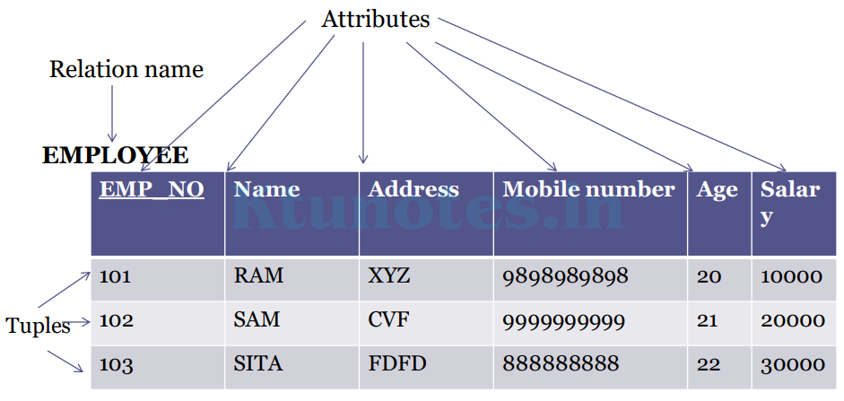
• In the relational model, all data is logically structured within relations (also called table)
• Informally a relation may be viewed as a named two-dimensional table representing an entity set.
• A relation has a fixed number of named columns and variable number of rows.
Components of relational database
• The main components of relational database structure are as follows:
1. Domains
2. Tuples (rows)
3. Columns
4. Keys
5. Relations (Tables)
Domain
• It has three parts--- ▫ Name ▫ Data type ▫ Format
• A Domain is a set of atomic values.
• Atomic means each value in the domain is indivisible to the relational model.
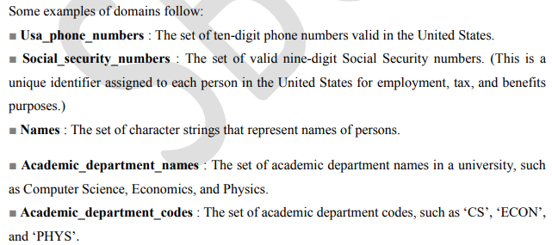
A domain may have a data-type or a format defined for it. The USA_phone_numbers may have a format: (ddd)-ddd-dddd where each d is a decimal digit. E.g., Dates have various formats such as month name, date, year or yyyy-mm-dd, or dd mm,yyyy etc.
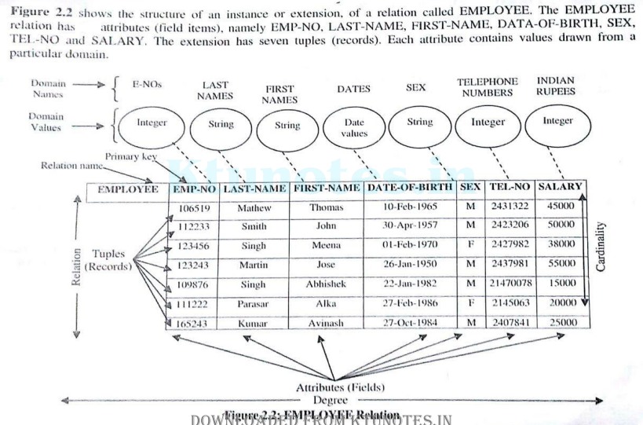
Tuples (rows)
• A tuple is an ordered set of values
• Tuple is a portion of a table containing data that described only entity, relationship, or object
• Also known as record
• Each value is derived from an appropriate domain.
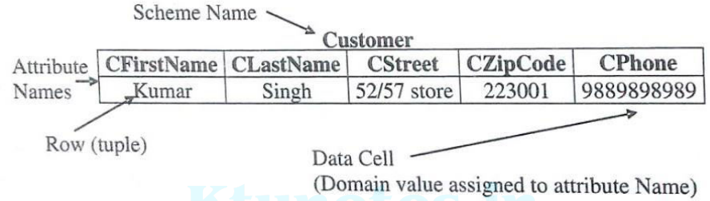
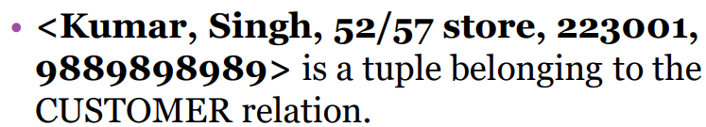
Columns
• Columns in a table are also called attributes or fields of the relation.
• A single cell in a table called field value, attribute value or data element.
• For example, for the entity person, attributes could include eye colour and height.
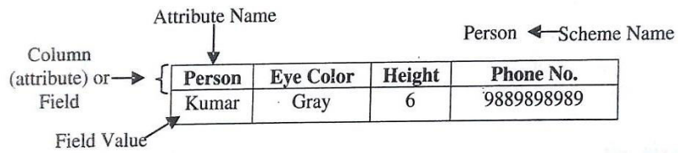
Key of a Relation
• Each row has a value of a data item (or set of items) that uniquely identifies that row in the table
Called the key
• Sometimes row-ids or sequential numbers are assigned as keys to identify the rows in a table
Called artificial key or surrogate key
Relations (Tables)
• A table of values
• A relation may be thought of as a set of rows.
• A relation may alternately be thought of as a set of columns.
• That is a table is perceived as a two-dimensional structure composed of rows and columns.
• Each row represents a fact that corresponds to a real-world entity or relationship.
• Each row has a value of an item or set of items that uniquely identifies that row in the table.
Sometimes row-ids or sequential numbers are assigned to identify the rows in the table.
Each column typically is called by its column name or column header or attribute name.
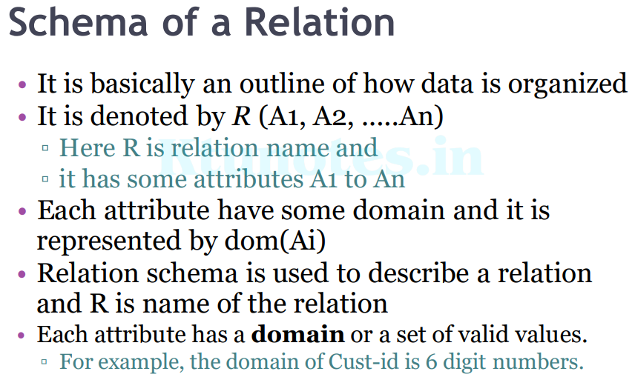
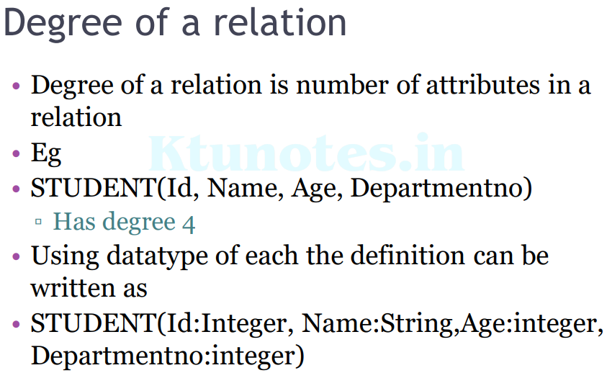
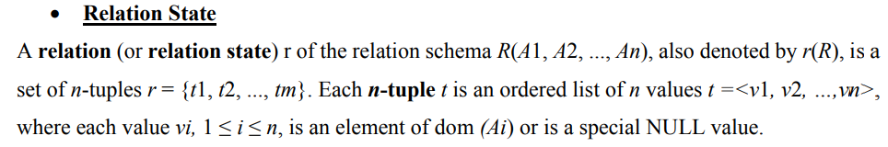
NULL values represent attributes whose values are unknown or do not exist for some individual tuple.
The earlier definition of a relation can be restated more formally using set theory concept as follows:
A relation state r(R) is a mathematical relation of degree n on the domains dom(A1), dom(A2)…, dom(An) which is a subset of the Cartesian product , X of domains that define R:
• Cartesian product specifies all possible combination of values from underlying domains
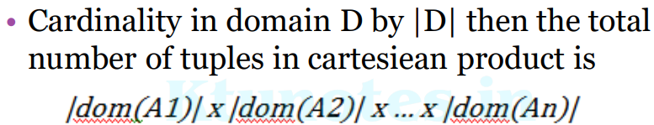
Characteristics of relations
The earlier definition of relations implies certain characteristics that make a relation different from a file or a table. Those characteristics are:
• Ordering of Tuples in a Relation
A relation is defined as a set of tuples. Mathematically, elements of a set have no order among them; hence, tuples in a relation do not have any particular order. However, in a file, records are physically stored on disk (or in memory), so there always is an order among the records. This ordering indicates first, second, ith, and last records in the file. Similarly, when we display a relation as a table, the rows are displayed in a certain order. Tuple ordering is not part of a relation definition because a relation attempts to represent facts at a logical or abstract level. Many tuple orders can be specified on the same relation.
- Ordering of Values within a Tuple and an Alternative Definition of a Relation
According to the preceding definition of a relation, an n-tuple is an ordered list of n values, so the ordering of values in a tuple—and hence of attributes in a relation schema—is important. An alternative definition of a relation can be given, making the ordering of values in a tuple unnecessary. According to this definition of tuple as a mapping, a tuple can be considered as a set of (<attribute>,<value>) pairs, where each pair gives the value of the mapping from an attribute Ai to a value vi from dom(Ai). The ordering of attributes is not important, because the attribute name appears with its value.
- Values and NULLs in the Tuples
Each value in a tuple is an atomic value; that is, it is not divisible into components within the framework of the basic relational model. Hence, composite and multivalued attributes are not allowed. This model is sometimes called the flat relational model.
In general, we can have several meanings for NULL values, such as value unknown, value exists but is not available, or attribute does not apply to this tuple (also known as value undefined).
Constraints on Relational Models OR Relational Integrity Constraints
- Integrity constraints are a set of rules. It is used to maintain the quality of information.
- Integrity constraints ensure that the data insertion, updating, and other processes have to be performed in such a way that data integrity is not affected.
- Thus, integrity constraint is used to guard against accidental damage to the database.
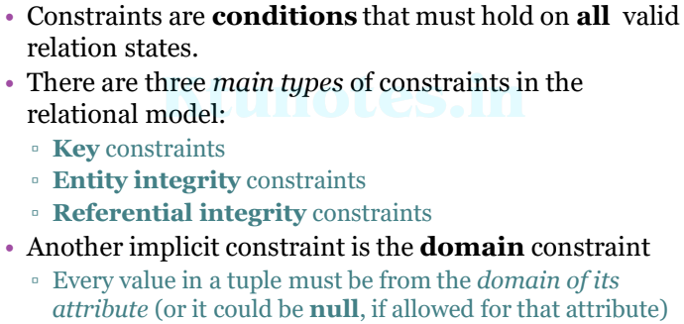
Key Constraints
- Keys are the entity set that is used to identify an entity within its entity set uniquely.
Key Constraints specifies that in a relation,
- All the values of primary key must be unique
- The value of primary key must not be null.
Example:
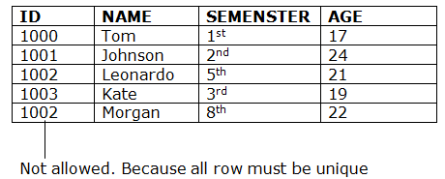

Table STUDENT
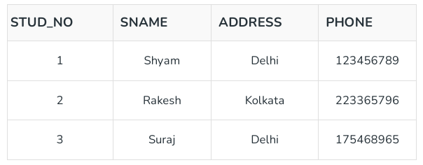

Candidate Key

The minimal set of attributes that can uniquely identify a tuple is known as a candidate key. For Example, STUD_NO in STUDENT relation , PHONE in STUDENT relation.
- It is a minimal super key.
- It can contain NULL values.
- It must contain unique values.
- Every table must have at least a single candidate key.
- A table can have multiple candidate keys but only one primary key.
- There can be more than one candidate key in a relationship.
- The candidate key can be simple (having only one attribute) or composite as well.
For ex: {STUD_NO, COURSE_NO} is a composite candidate key for relation STUDENT_COURSE.
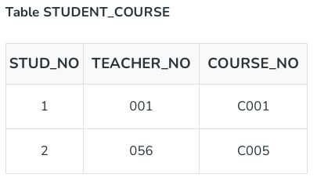

Primary Key
There can be more than one candidate key in relation out of which one can be chosen as the primary key. For Example, STUD_NO, as well as STUD_PHONE, are candidate keys for relation STUDENT but STUD_NO can be chosen as the primary key (only one out of many candidate keys).
- It is a unique key.
- It can identify only one tuple (a record) at a time.
- It has no duplicate values, it has unique values.
- It cannot be NULL.
- Primary keys are not necessarily to be a single column; more than one column can also be a primary key for a table.

▫ The primary key attributes are underlined.

• Example: Consider the CAR relation schema:

▫ CAR(State, Reg#, SerialNo, Make, Model, Year)

▫ We chose SerialNo as the primary key

• The primary key value is used to uniquely identify each tuple in a relation.

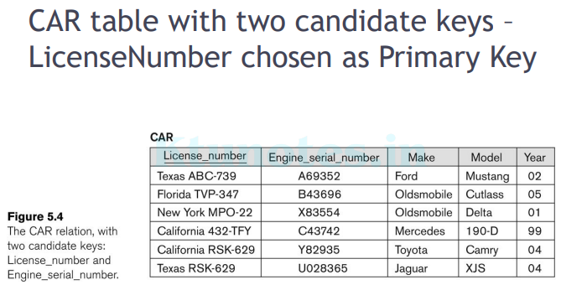

Super Key
Adding zero or more attributes to the candidate key generates the super key.
OR
The set of attributes that can uniquely identify a tuple is known as Super Key.
For Example, STUD_NO, (STUD_NO, SNAME), (STUD_NO, SNAME, ADDRESS), etc can be super keys.
A super key is a group of single or multiple keys that identifies rows in a table. It supports NULL values.
- A candidate key is a super key but vice versa is not true.

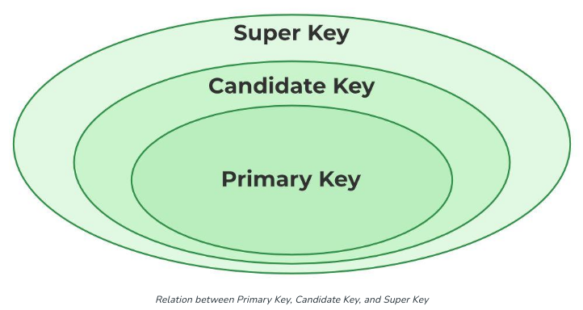

Alternate Key
The candidate key other than the primary key is called an alternate key.
- All the keys which are not primary keys are called alternate keys.
- It is a secondary key.
- It contains two or more fields to identify two or more records.
- These values are repeated.
- Eg:- SNAME, and ADDRESS is Alternate keys
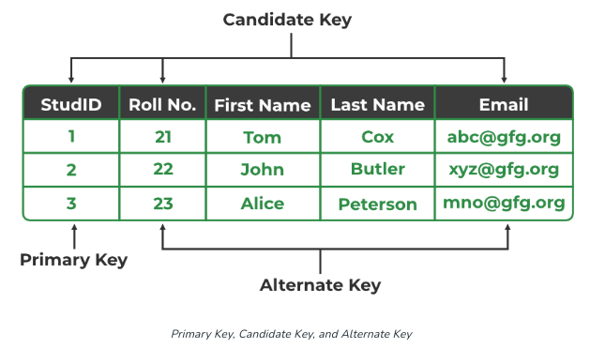
Composite Key
A primary key comprising of multiple attributes and not just a single attribute is called as a composite key.
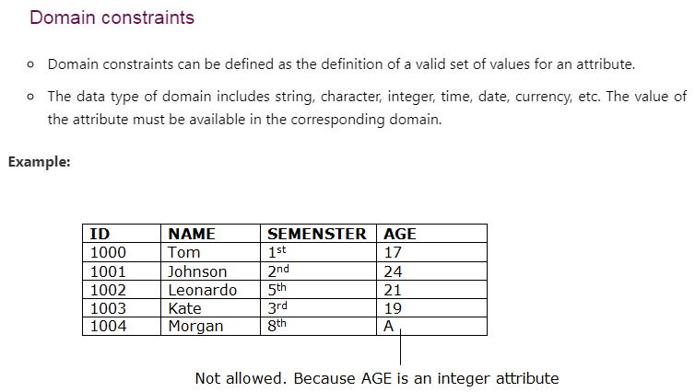
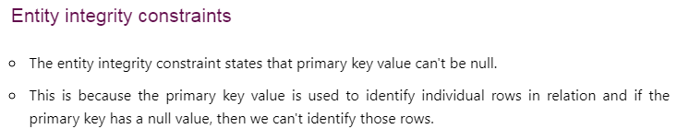
Example:
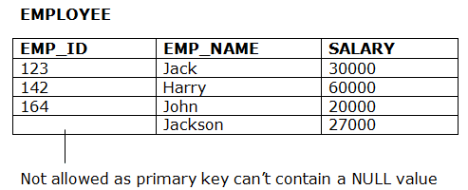

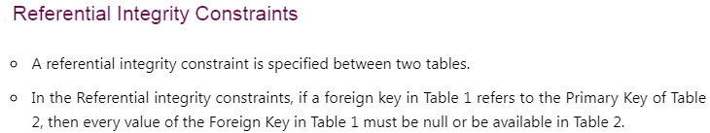
Example:
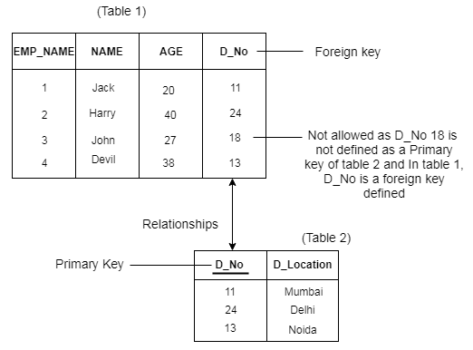
Foreign Key
A FOREIGN KEY is a field (or collection of fields) in one table, that refers to the PRIMARY KEY in another table.
If an attribute can only take the values which are present as values of some other attribute, it will be a foreign key to the attribute to which it refers. The relation which is being referenced is called referenced relation and the corresponding attribute is called referenced attribute. The relation which refers to the referenced relation is called referencing relation and the corresponding attribute is called referencing attribute. The referenced attribute of the referenced relation should be the primary key to it.
- It is a key which acts as a primary key in one table and it acts as
secondary key in another table.
- It combines two or more relations (tables) at a time.
- They act as a cross-reference between the tables.
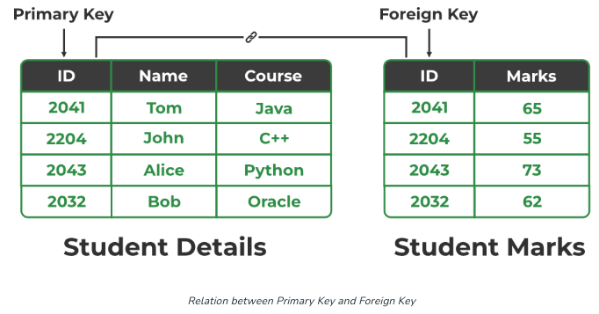

Here Student Details table is called Referenced relation or master table or primary table and the ID in that table is the referenced attribute.
Here Student Marks table is called Referencing relation or foreign table and the ID in that table is the referencing attribute.
- Foreign key references the primary key of the table.
- Foreign key can take only those values which are present in the primary key of the referenced relation.
- Foreign key may have a name other than that of a primary key.

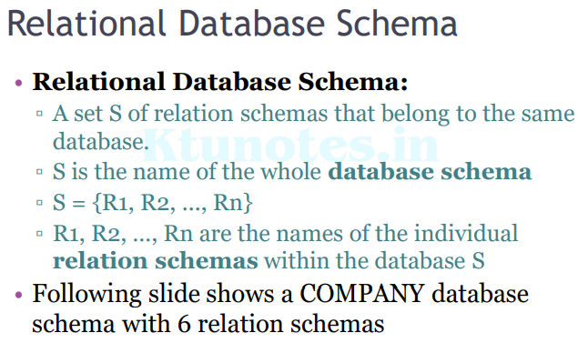

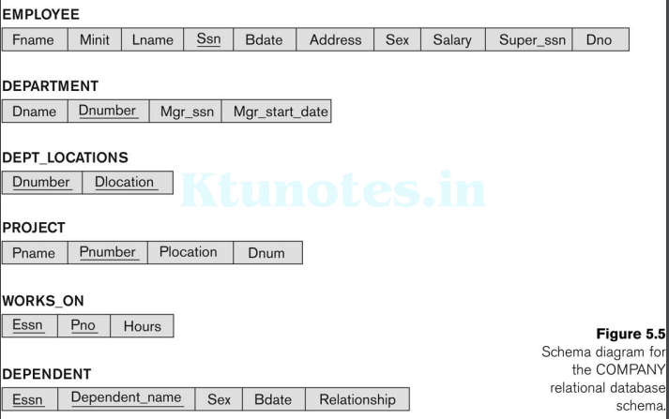
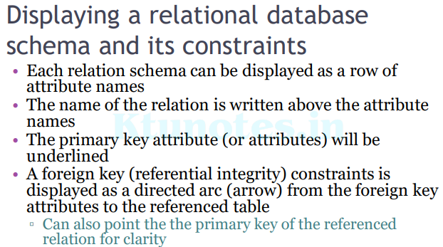
• Below figure shows the COMPANY relational schema diagram
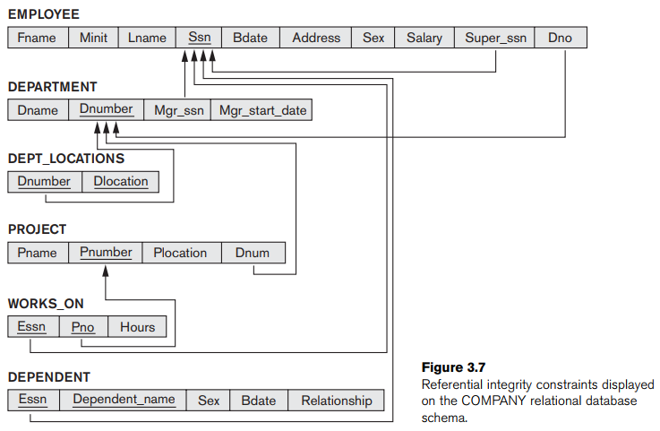
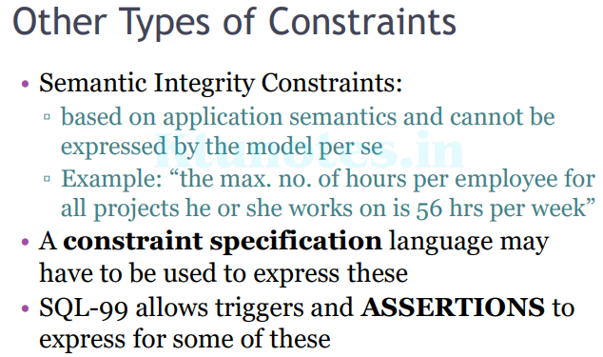
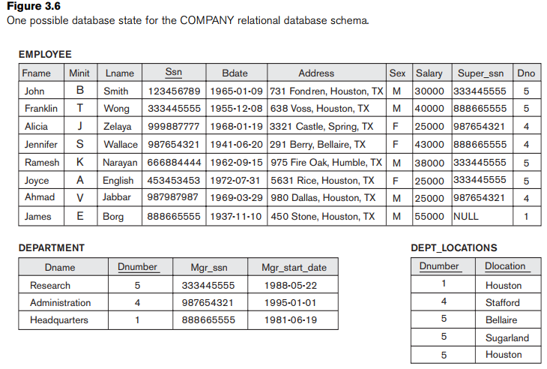
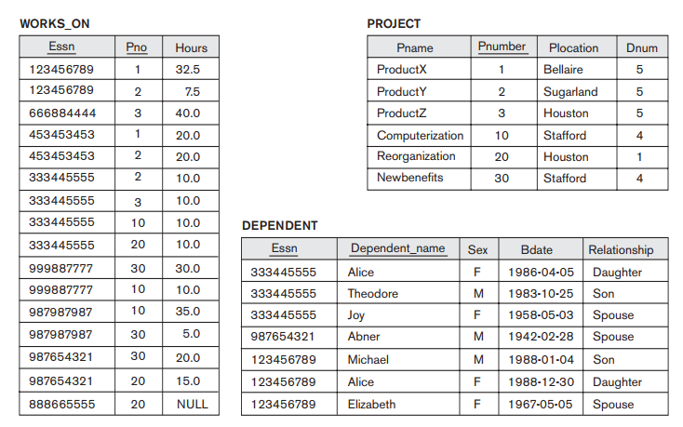
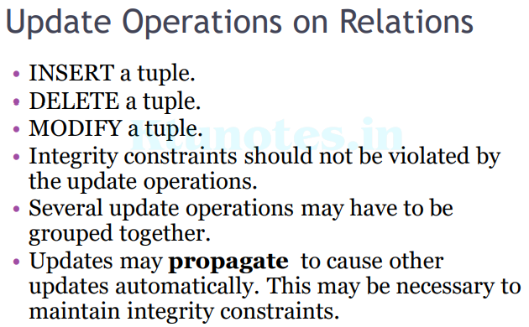
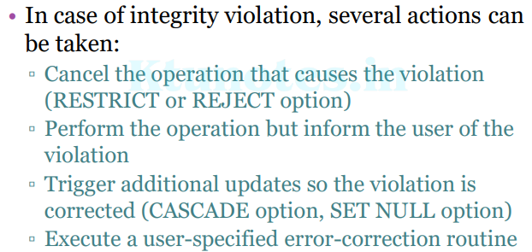
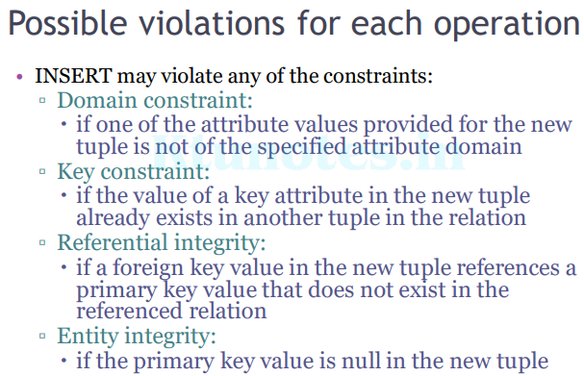
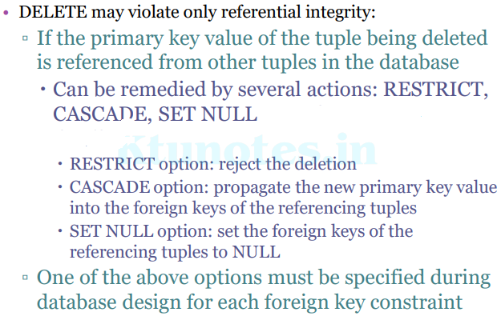
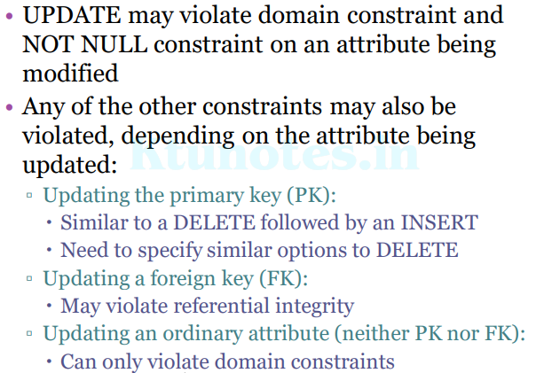
Consider the following relations for a database that keeps track of student enrollment in courses and the books adopted for each course:
STUDENT (Ssn, Name, Major, Bdate)
COURSE (Course#, Cname, Dept)
ENROLL (Ssn, Course#, Quarter, Grade)
BOOK_ADOPTION (Course#, Quarter, Book_isbn)
TEXT (Book_isbn, Book_title, Publisher, Author)
Specify the foreign keys for this schema , stating any assumptions you make.
Answer:
This schema has the following 4 foreign keys
  - The attribute Ssn of relation ENROLL that references relation STUDENT.
  - The attribute Course# in relation ENROLL that references relation COURSE.
  - The attribute Course# in relation BOOK_ADOPTION that references relation COURSE.
  - The attribute Book_isbn of relation BOOK_ADOPTION that references relation TEXT.
Synthesizing ER diagram to Relational Schema
After designing an ER Diagram,
• ER diagram is converted into the tables in relational model.
• This is because relational models can be easily implemented by RDBMS like MySQL , Oracle etc.
Following rules are used for converting an ER diagram into the tables:

Rule-01: For Strong Entity Set With Only Simple Attributes:
A strong entity set with only simple attributes will require only one table in relational model.
• Attributes of the table will be the attributes of the entity set.
• The primary key of the table will be the key attribute of the entity set.
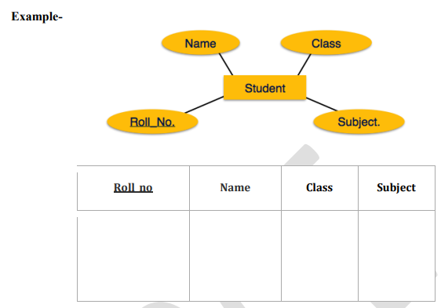
Schema:Student(Roll_no, Name, Class, Subject)

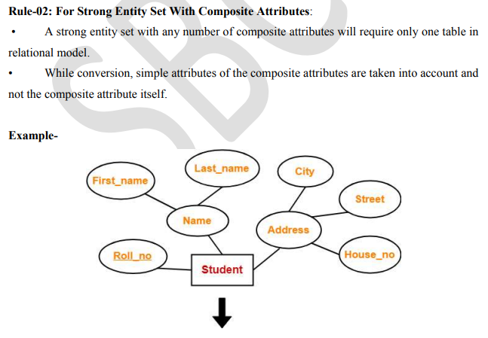
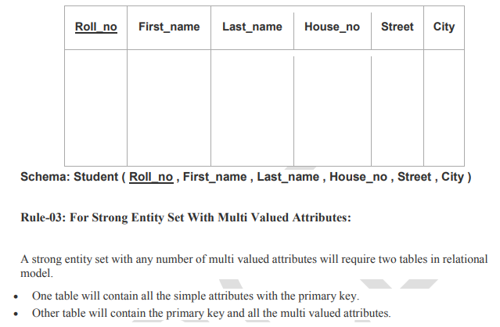
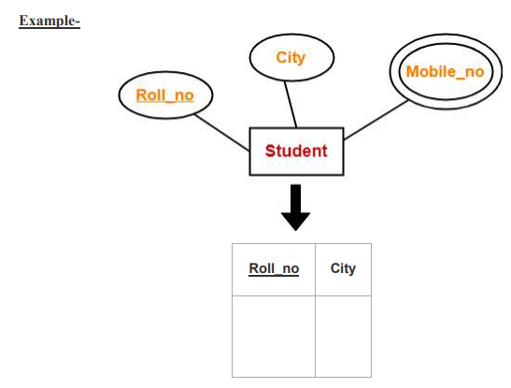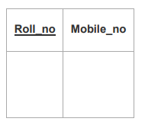
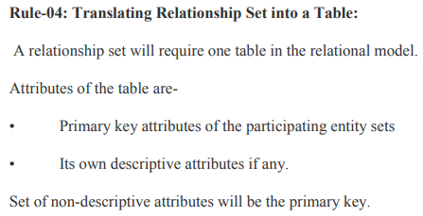
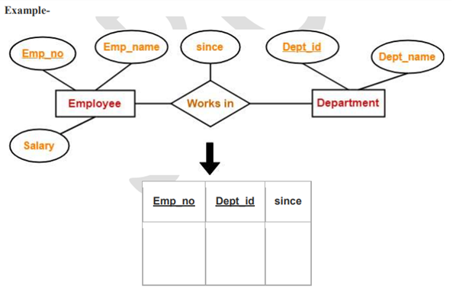

Schema: Works_in(Emp_no,Dept_id,since)
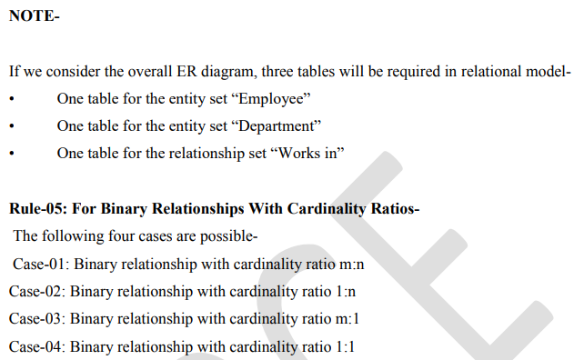
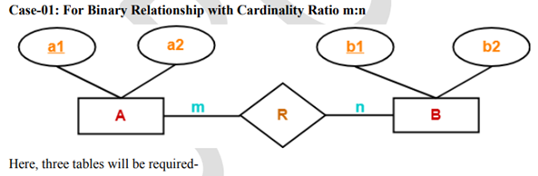
- A (a1 , a2)
- R (a1 , b1)
- B (b1 , b2)
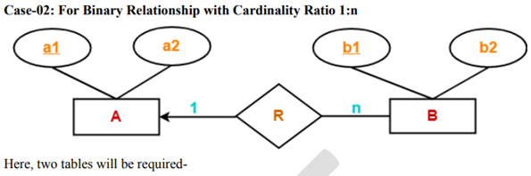
- A(a1 , a2)
- BR(a1 , b1 , b2)
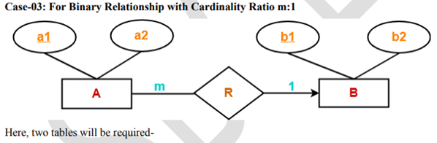
- AR(a1 , a2 , b1)
- B(b1 , b2)
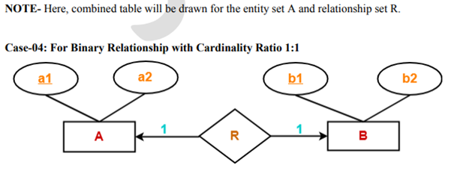
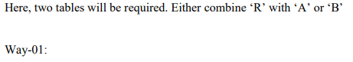
- AR(a1 , a2 , b1)
- B(b1 , b2)

Way-02:
- A(a1 , a2)
- BR(a1 , b1 , b2)
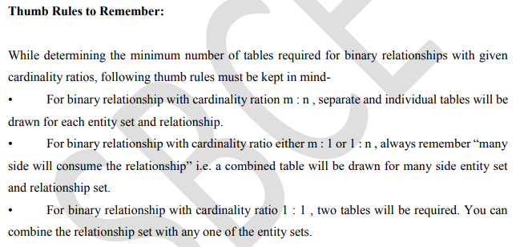
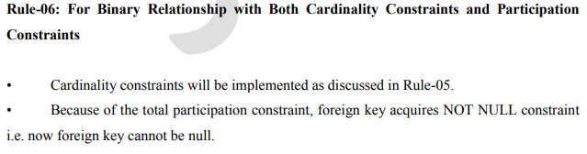
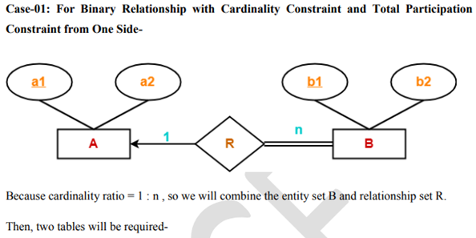
- A(a1 , a2)
- BR(a1 , b1 , b2)
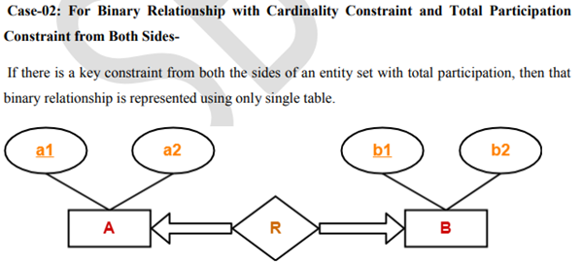
Here only one table is required. ARB(a1 , a2 , b1 , b2)
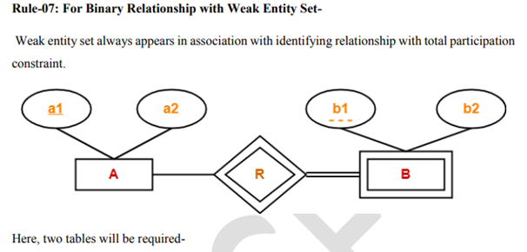
- A(a1 , a2)
- BR(a1 , b1 , b2)

Introduction to Relational Algebra
Relational algebra is a procedural query language, which takes instances of relations as input and yields instances of relations as output.
• It uses operators to perform queries. An operator can be either unary or binary.
Relational Algebra divided into various groups.
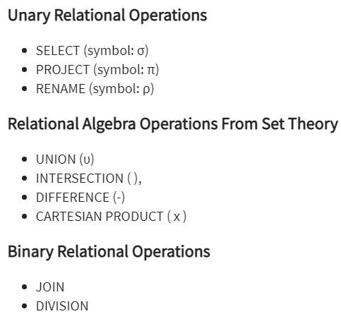

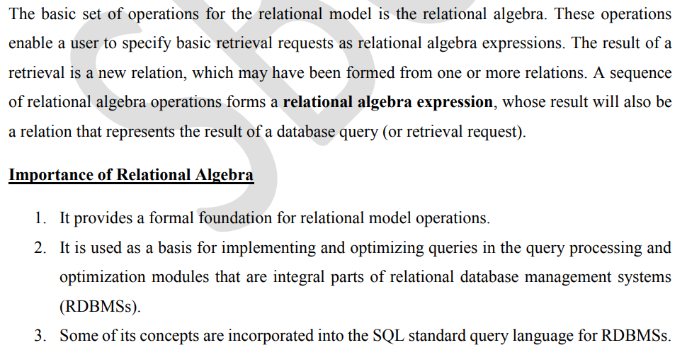
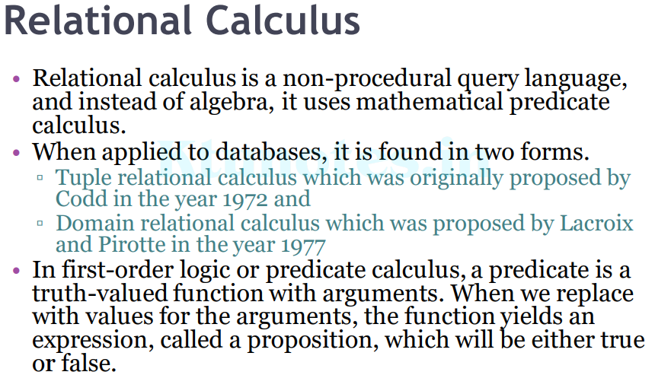
Unary Relational Operations: SELECT and PROJECT
The SELECT Operation
- The SELECT operation is used to choose a subset of the tuples from a relation that satisfies a selection condition. In general, the SELECT operation is denoted by
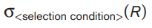
where the symbol σ (sigma) is used to denote the SELECT operator and the selection condition is a Boolean expression (condition) specified on the attributes of relation R.
Ex: Select tuples from a relation “Books” where subject is “DBMS”
σ _{subject=DBMS}(Books)
- SELECT operation do horizontal partition of the relation into two sets of tuples
- Those tuples that satisfy the condition are selected, and those tuples that do not satisfy the condition are discarded.
- The relation resulting from the SELECT operation has the same attributes as R.
- The Boolean expression specified in is made up of a number of clauses of the form
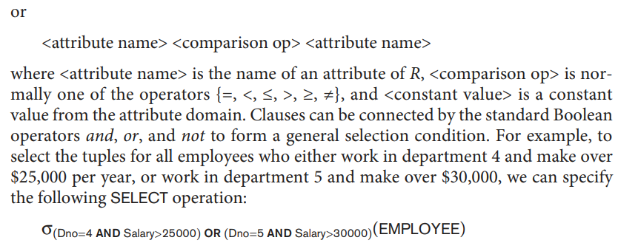
The result is shown below:
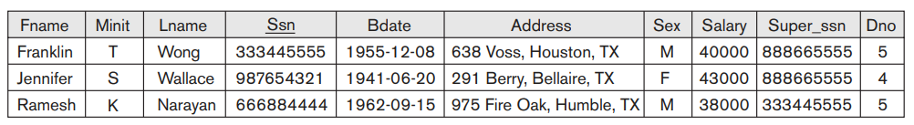
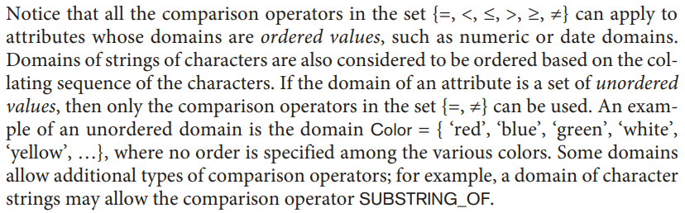
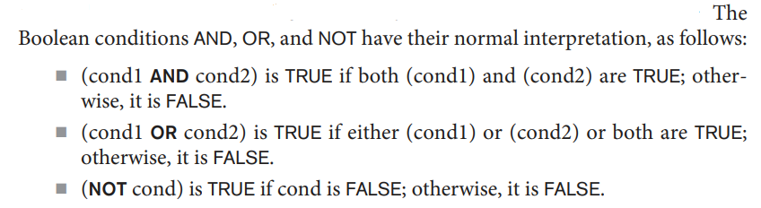
- The SELECT operator is unary; that is, it is applied to a single relation.
- The degree of the relation resulting from a SELECT operation—its number of attributes—is the same as the degree of R. The number of tuples in the resulting relation is always less than or equal to the number of tuples in R. That is, |σc (R)| ≤ |R| for any condition C. The fraction of tuples selected by a selection condition is referred to as the selectivity of the condition.
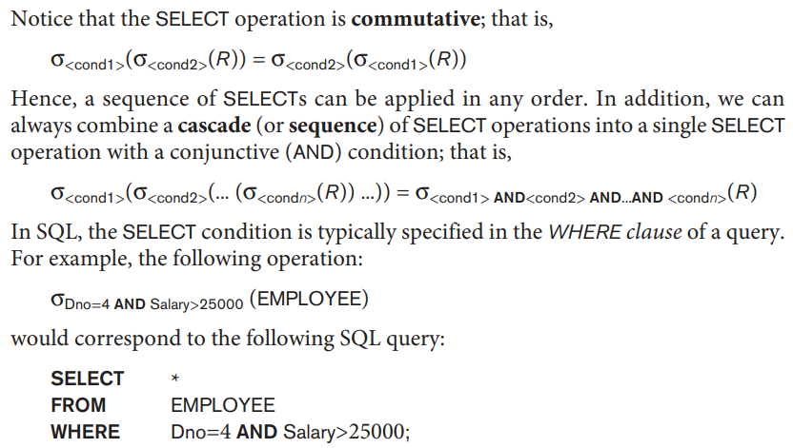
The PROJECT Operation
If we think of a relation as a table, the SELECT operation chooses some of the rows from the table while discarding other rows. The PROJECT operation, on the other hand, selects certain columns from the table and discards the other columns. If we are interested in only certain attributes of a relation, we use the PROJECT operation to project the relation over these attributes only. The general form of the PROJECT operation is
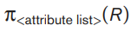
where π (pi) is the symbol used to represent the PROJECT operation, and <attribute list> is the desired sublist of attributes from the attributes of relation R.
Query: List each employee’s first and last name and salary.
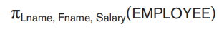
The resulting relation is shown in Figure:
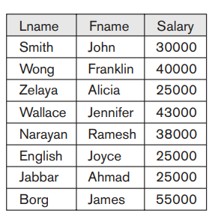
The result of the PROJECT operation has only the attributes specified in <attribute list> in the same order as they appear in the list. Hence, its degree is equal to the number of attributes in <attribute list>.
The PROJECT operation removes any duplicate tuples, so the result of the PROJECT operation is a set of distinct tuples, and hence a valid relation. This is known as duplicate elimination. For example, consider the following PROJECT operation:
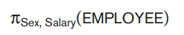
The result is shown in Figure below. Notice that the tuple <’F’,25000> appears only once in Figure, even though this combination of values appears twice in the EMPLOYEE relation.
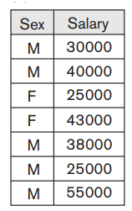
If duplicates are not eliminated, the result would be a multiset or bag of tuples rather than a set. This was not permitted in the formal relational model but is allowed in SQL.
The number of tuples in a relation resulting from a PROJECT operation is always less than or equal to the number of tuples in R.
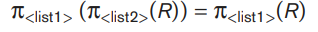
as long as contains the attributes in ;otherwise, the left-hand side is an incorrect expression.
• commutativity does not hold on PROJECT.
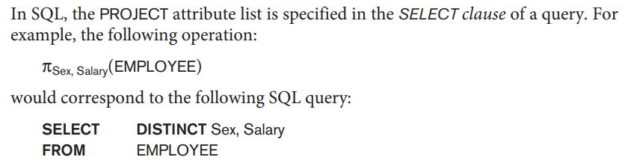
By using DISTINCT keyword, we can eliminate duplicate values.
Sequences of Operations and the RENAME Operation

In general, for most queries, we need to apply several relational algebra operations one after the other. Either we can write the operations as a single relational algebra expression by nesting the operations, or we can apply one operation at a time and create intermediate result relations. In the latter case, we must give names to the relations that hold the intermediate results.
For example, to retrieve the first name, last name, and salary of all employees who work in department number 5, we must apply a SELECT and a PROJECT operation. We can write a single relational algebra expression, also known as an in-line expression, as follows:
Figure below shows the result of this in-line relational algebra expression.
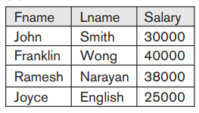
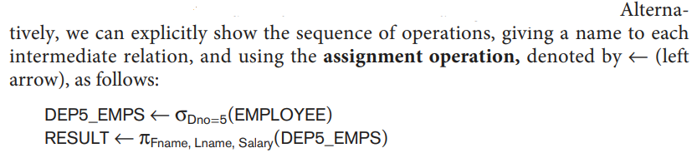
We can also use this technique to rename the attributes in the intermediate and result relations. This can be useful in connection with more complex operations such as UNION and JOIN. To rename the attributes in a relation, we simply list the new attribute names in parentheses, as in the following example:
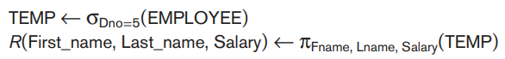
These two operations are illustrated in Figure below:
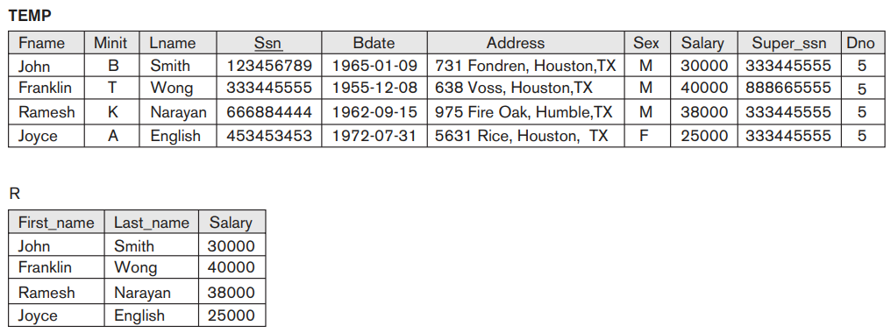
Figure: Using intermediate relations and renaming of attributes
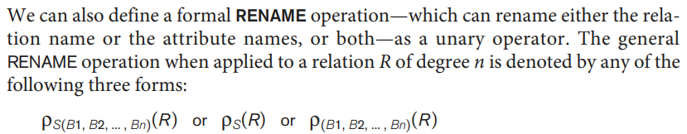
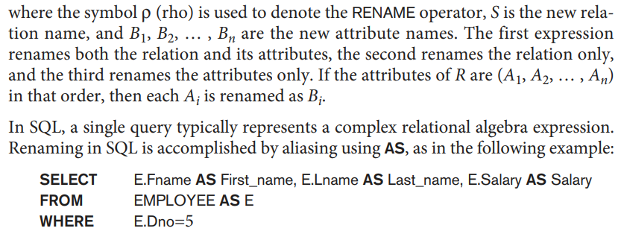
Relational Algebra Operations from Set Theory
The UNION, INTERSECTION, and MINUS Operations
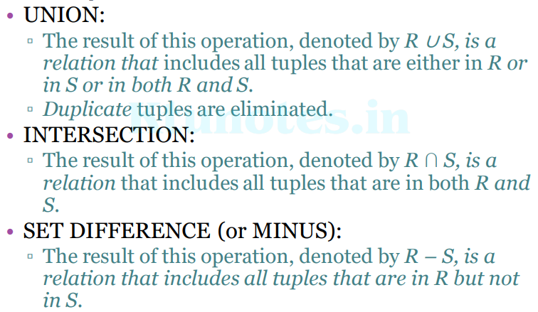
SET DIFFERENCE is also called EXCEPT.
UNION, INTERSECTION, and SET DIFFERENCE are binary operations;
▫ that is, each is applied to two sets
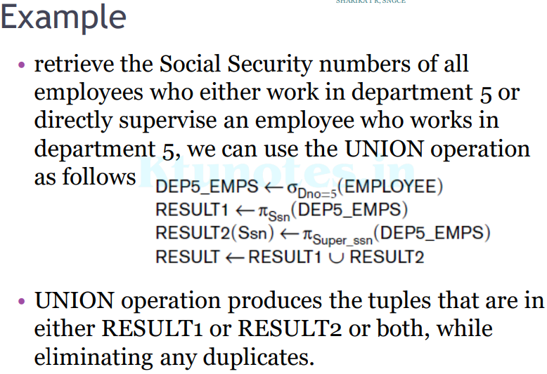
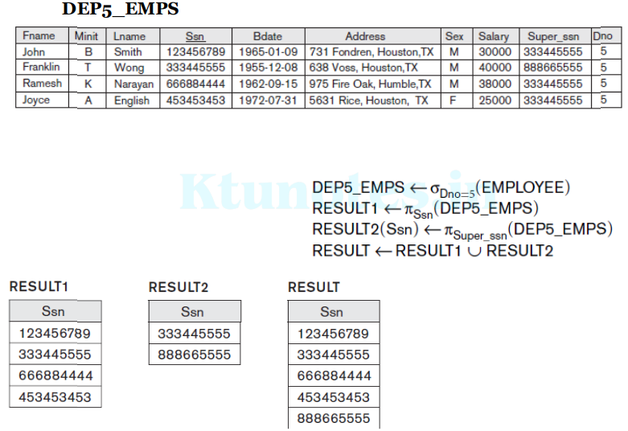
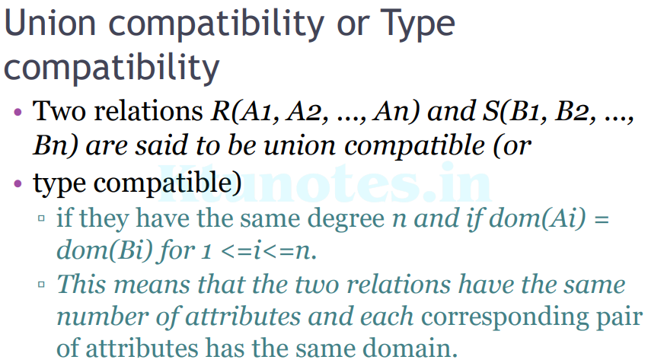
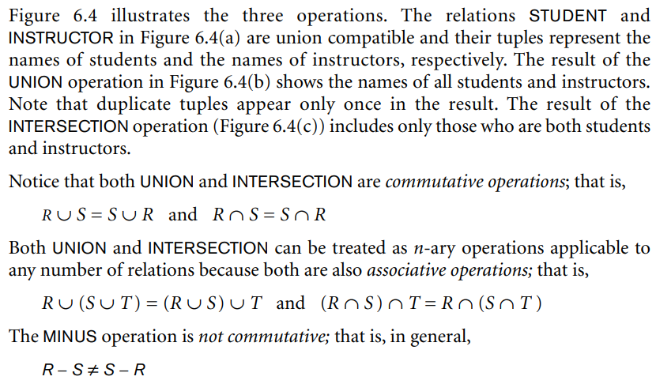
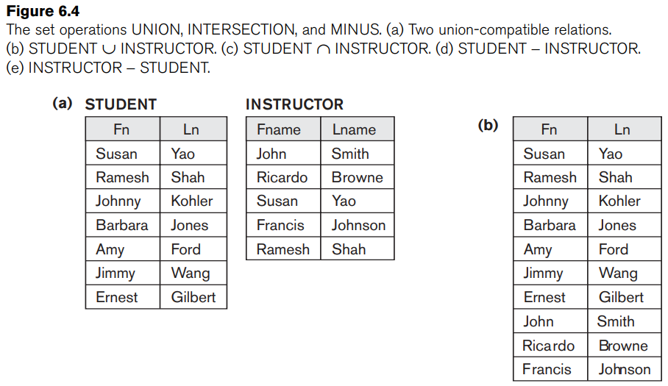
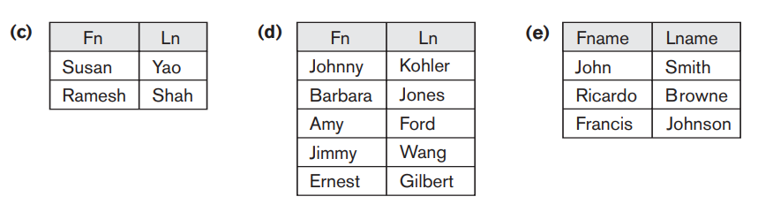
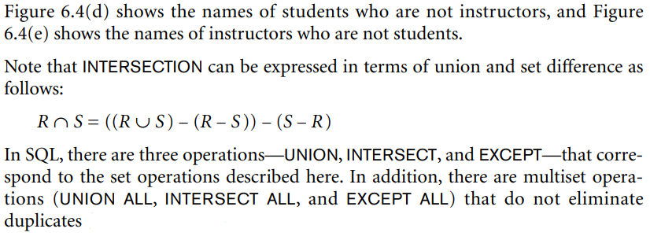
The CARTESIAN PRODUCT (CROSS PRODUCT) Operation
CARTESIAN PRODUCT operation—also known as CROSS PRODUCT or CROSS JOIN—which is denoted by ×. This is also a binary set operation, but the relations on which it is applied do not have to be union compatible. In its binary form, this set operation produces a new element by combining every member (tuple) from one relation (set) with every member (tuple) from the other relation (set).
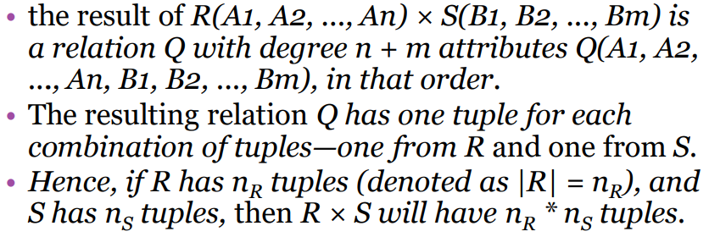
The n-ary CARTESIAN PRODUCT operation is an extension of the above concept, which produces new tuples by concatenating all possible combinations of tuples from n underlying relations.
Example
• We want to retrieve a list of names of each female employee’s dependents.
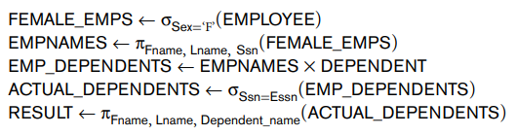
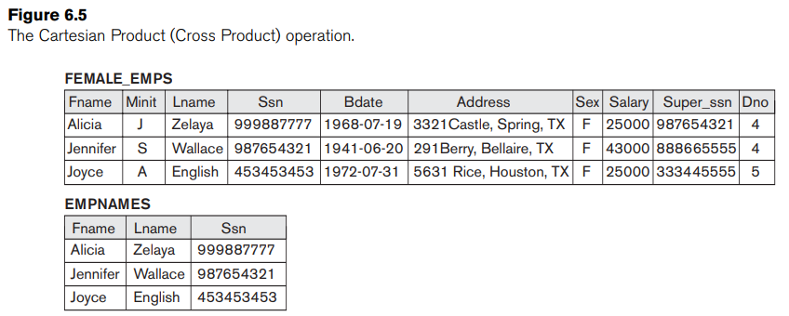
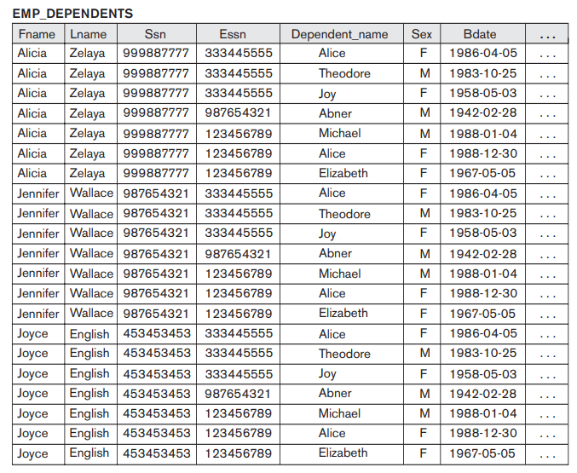
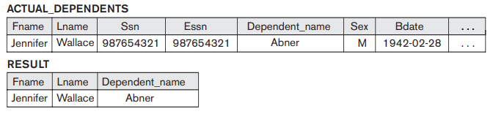
- The CARTESIAN PRODUCT creates tuples with the combined attributes of two relations.
- We can SELECT related tuples only from the two relations by specifying an appropriate selection condition after the Cartesian product, as we did in the preceding example.
- Because this sequence of CARTESIAN PRODUCT followed by SELECT is quite commonly used to combine related tuples from two relations, a special operation, called JOIN, was created to specify this sequence as a single operation.
- In SQL, CARTESIAN PRODUCT can be realized by using the CROSS JOIN option in joined tables. Alternatively, if there are two tables in the WHERE clause and there is no corresponding join condition in the query, the result will also be the CARTESIAN PRODUCT of the two tables.
Binary Relational Operations: JOIN and DIVISION
The JOIN Operation
• The JOIN operation, denoted by  , is used to combine related tuples from two relations into single “longer” tuples.
• This operation is very important for any relational database with more than a single relation because it allows us to process relationships among relations.
Example
• Retrieve the name of the manager of each department.
▫ To get the manager’s name, we need to combine each department tuple with the employee tuple whose Ssn value matches the Mgr_ssn value in the department tuple.
▫ We do this by using the JOIN operation and then projecting the result over the necessary attributes, as follows:
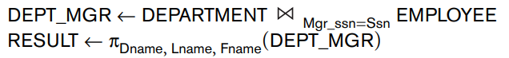
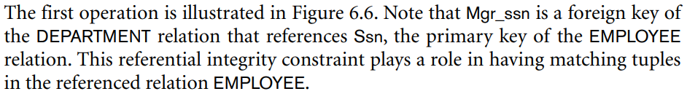
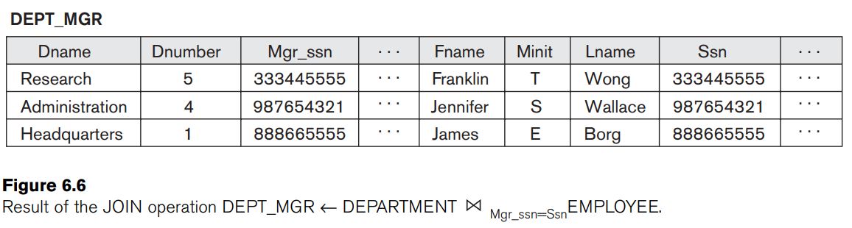
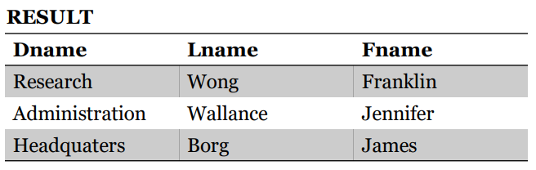
The JOIN operation can be specified as a CARTESIAN PRODUCT operation followed by a SELECT operation.
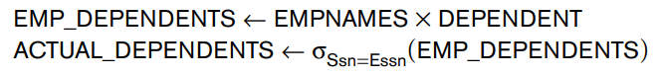
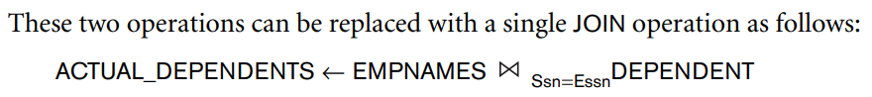
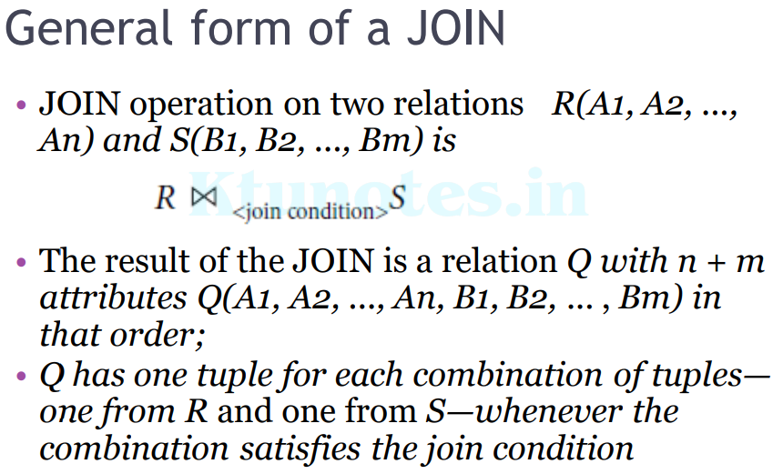
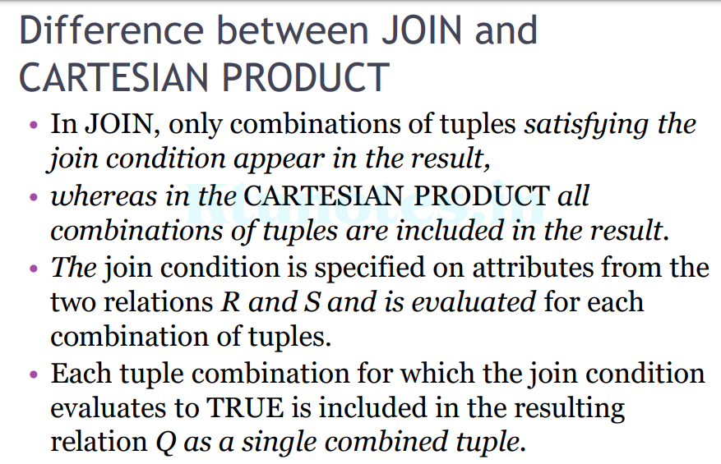
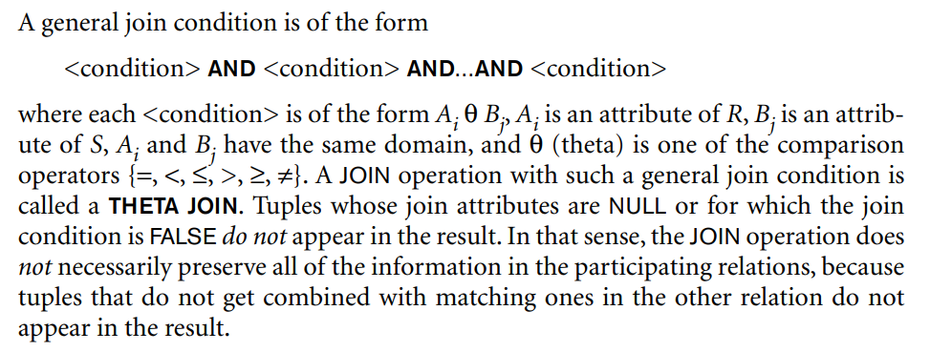
Variations of JOIN: The EQUIJOIN and NATURAL JOIN
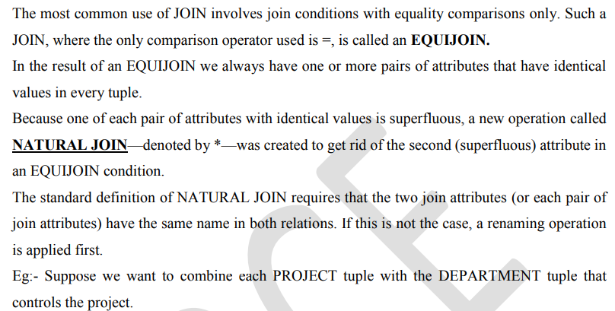
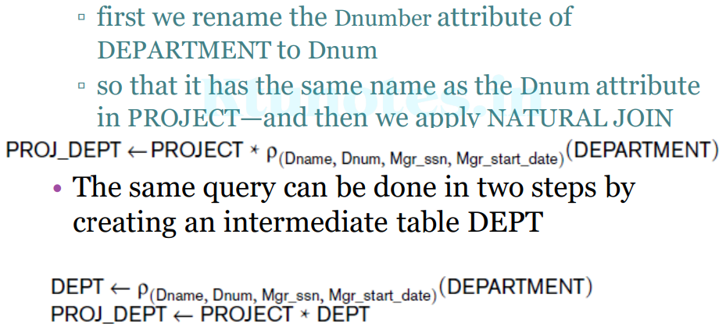
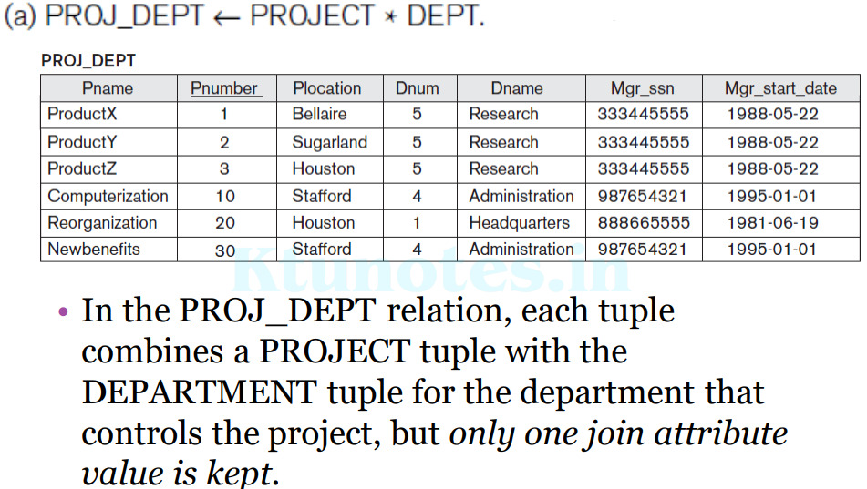
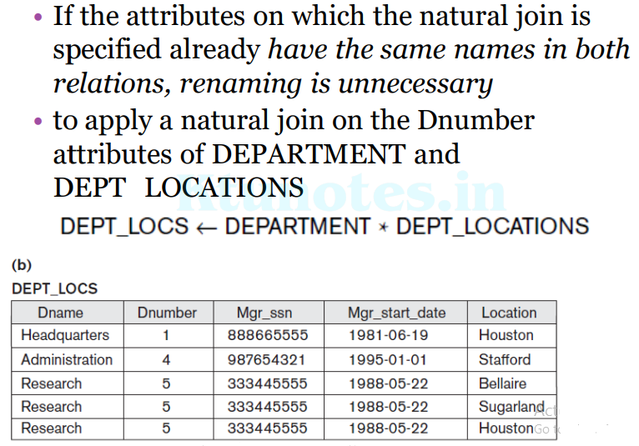
- The join condition for NATURAL JOIN is constructed by equating each pair of join attributes that have the same name in the two relations and combining these conditions with AND.
- There can be a list of join attributes from each relation, and each corresponding pair must have the same name.
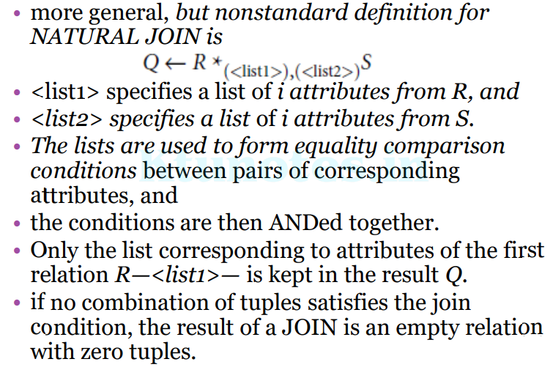

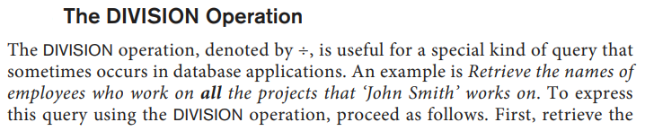
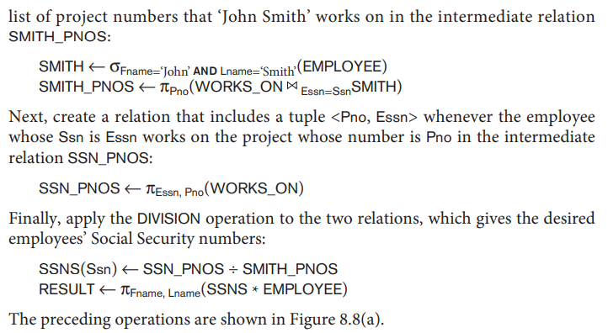
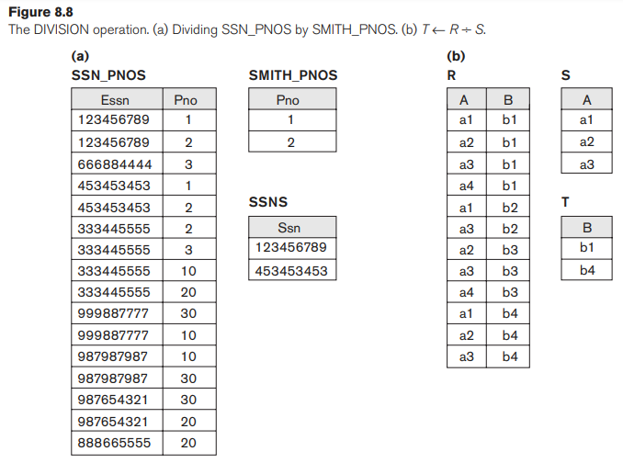
For a tuple t to appear in the result T of the DIVISION, the values in t must appear in R in combination with every tuple in S.
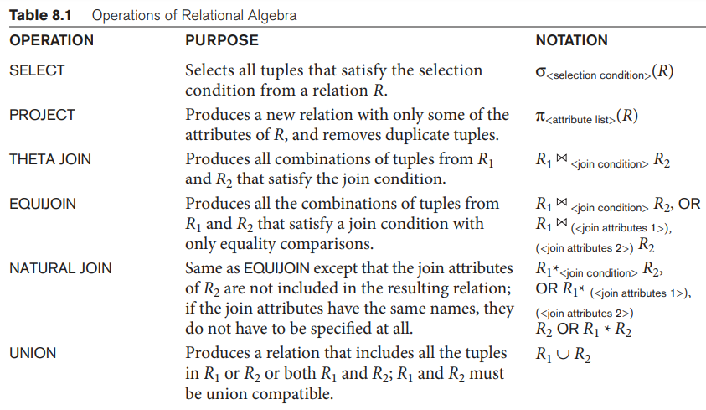
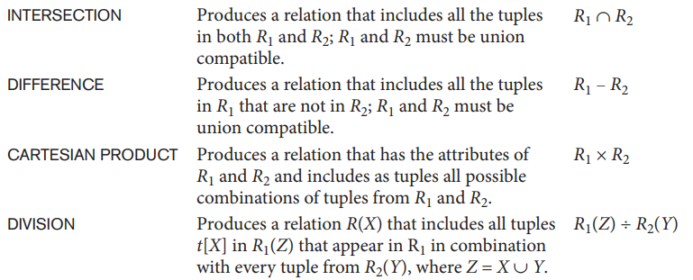
Additional Relational Operations
Some common database requests—which are needed in commercial applications for RDBMSs— cannot be performed with the original relational algebra operations. Additional operations are defined to express these requests. These operations enhance the expressive power of the original relational algebra.

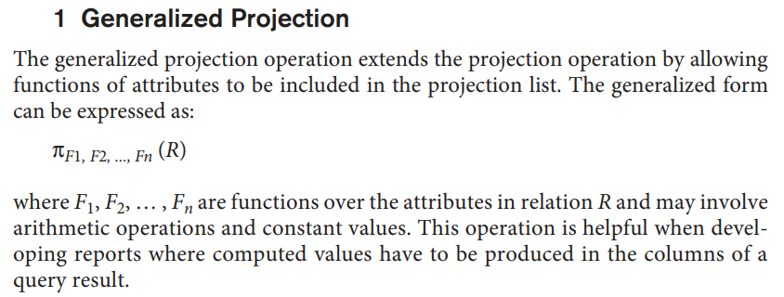
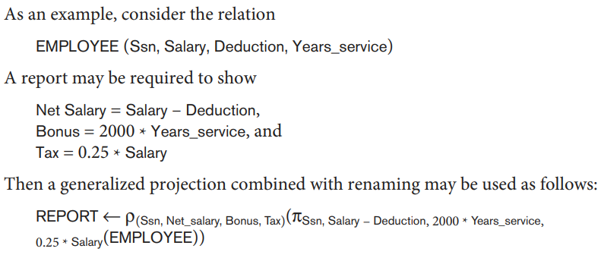

- Another type of request that cannot be expressed in the basic relational algebra is to specify mathematical aggregate functions on collections of values from the database.
- Common functions applied to collections of numeric values include SUM, AVERAGE, MAXIMUM, and MINIMUM. The COUNT function is used for counting tuples or values.
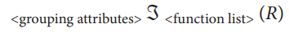

Query: Retrieve each department number, the number of employees in the department, and their average salary.
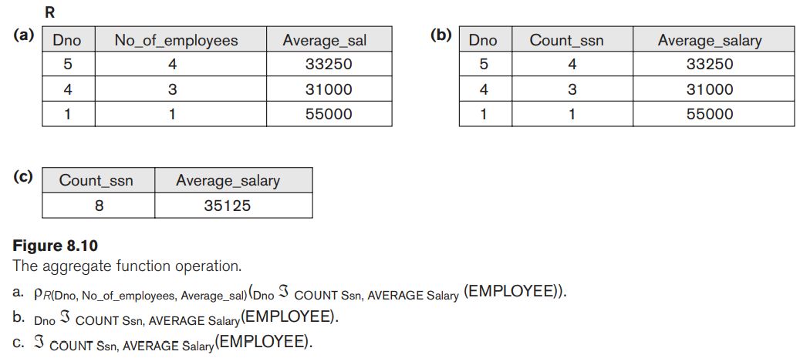
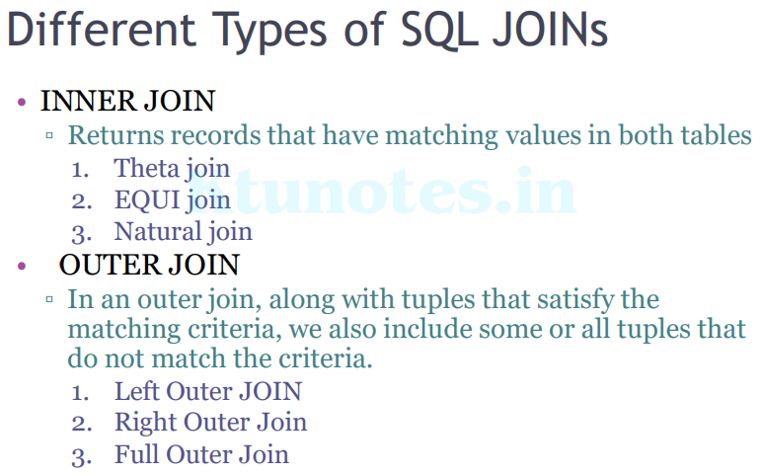
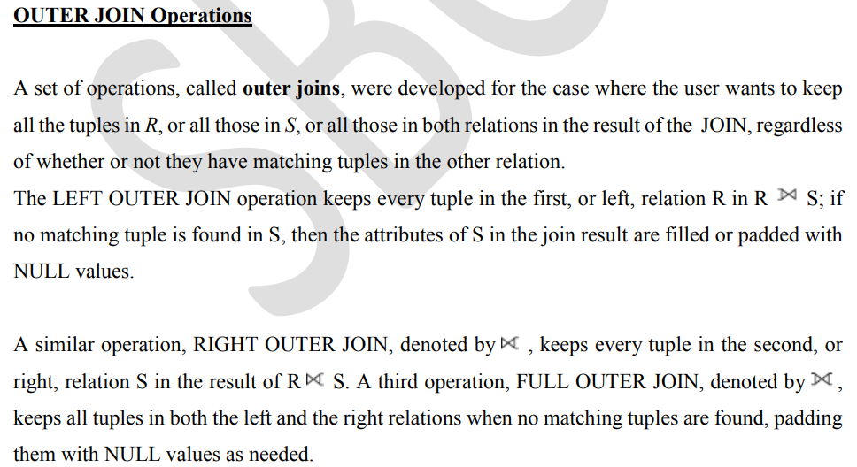
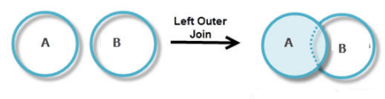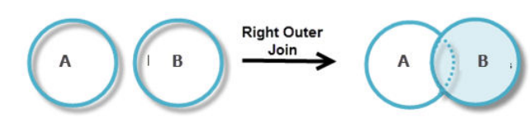
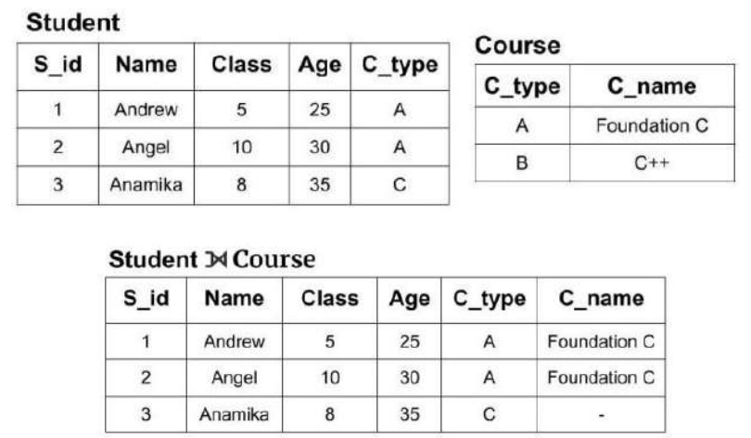
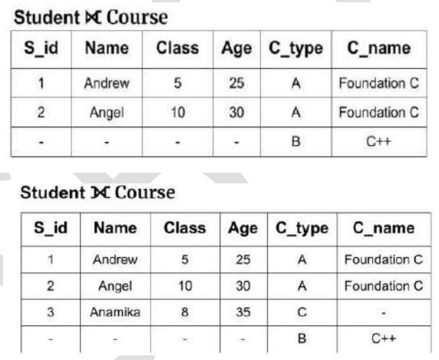
QUERY EXAMPLES

Introduction to Structured Query Language (SQL)
- The SQL language may be considered one of the major reasons for the commercial success of relational databases.
- The SQL language provides a higher-level declarative language interface, so the user only specifies what the result is to be, leaving the actual optimization and decisions on how to execute the query to the DBMS.
- The name SQL is presently expanded as Structured Query Language.
- Originally, SQL was called SEQUEL (Structured English QUEry Language) and was designed and implemented at IBM Research as the interface for an experimental relational database system called SYSTEM R.
- SQL is now the standard language for commercial relational DBMSs.
- SQL is a comprehensive database language: It has statements for data definitions, queries, and updates. Hence, it is both a DDL and a DML.
- In addition, it has facilities for defining views on the database, for specifying security and authorization, for defining integrity constraints, and for specifying transaction controls.
- It also has rules for embedding SQL statements into a general purpose programming language such as Java, COBOL, or C/C++.
SQL Data Definition and Data Types
- E/R designs can be implemented in SQL.
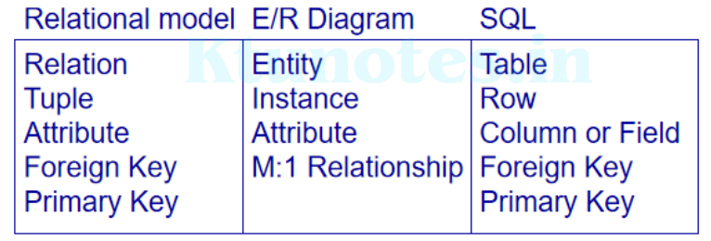
Implementing E/R Designs
• Given an E/R design
▫ The entities become SQL tables.
▫ The name of the table is often the name of the entity.
▫ Attributes of an entity become columns in the corresponding table.
▫ Relationships may be represented by foreign keys.
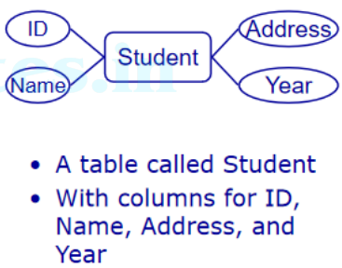
Schema and Catalog Concepts in SQL
- The concept of an SQL schema was incorporated starting with SQL2 in order to group together tables and other constructs that belong to the same database application.
- An SQL schema is identified by a schema name and includes an authorization identifier to indicate the user or account who owns the schema, as well as descriptors for each element in the schema.
- Schema elements include tables, types, constraints, views, domains, and other constructs (such as authorization grants) that describe the schema.
- A schema is created via the CREATE SCHEMA statement, which can include all the schema elements’ definitions.
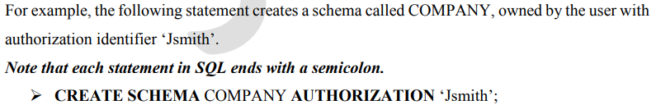
- In general, not all users are authorized to create schemas and schema elements. The privilege to create schemas, tables, and other constructs must be explicitly granted to the relevant user accounts by the system administrator or DBA.
- In addition to the concept of a schema, SQL uses the concept of a catalog—a named collection of schemas.
- A catalog always contains a special schema called INFORMATION_SCHEMA, which provides information on all the schemas in the catalog and all the element descriptors in these schemas.
- Integrity constraints such as referential integrity can be defined between relations only if they exist in schemas within the same catalog. Schemas within the same catalog can also share certain elements, such as type and domain definitions.
The CREATE DATABASE Command
• A Database is defined as a structured set of data. So, in SQL the very first step to store the data in a well-structured manner is to create a database.
• The CREATE DATABASE statement is used to create a new database in SQL.
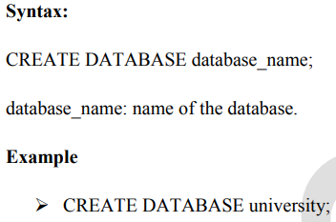

DATABASE LANGUAGES
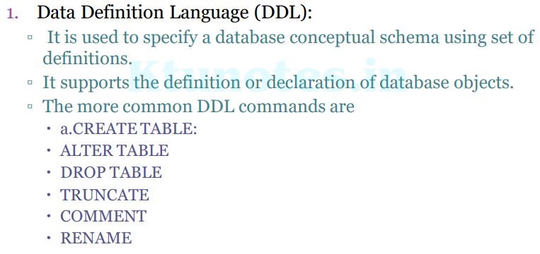
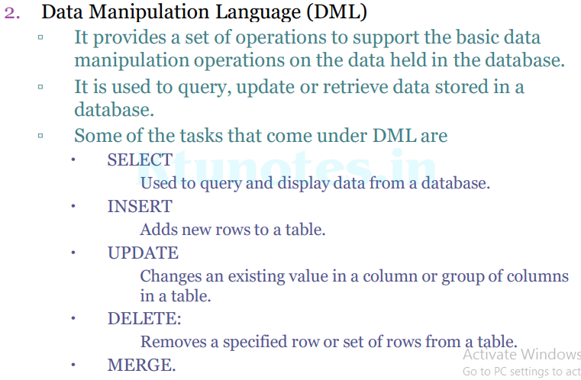
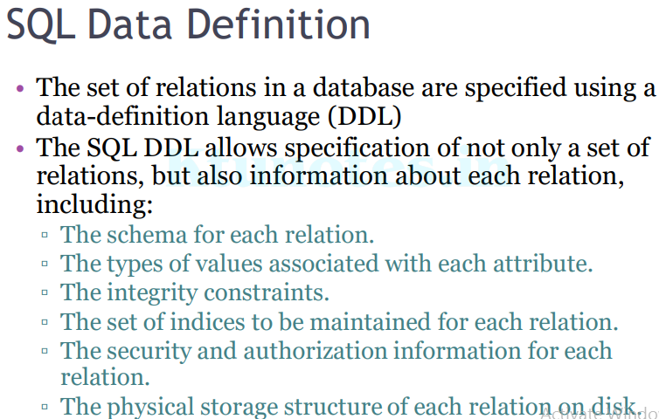
The CREATE TABLE Command
• The CREATE TABLE command is used to specify a new relation by giving it a name and specifying its attributes and initial constraints.
• The attributes are specified first, and each attribute is given a name, a data type to specify its domain of values, and any attribute constraints, such as NOT NULL.
• The key, entity integrity, and referential integrity constraints can be specified within the CREATE TABLE statement after the attributes are declared, or they can be added later using the ALTER TABLE command.
• The relations declared through CREATE TABLE statements are called base tables (or base relations); this means that the relation and its tuples are actually created and stored as a file by the DBMS.
• Base relations are distinguished from virtual relations, created through the CREATE VIEW statement, which may or may not correspond to an actual physical file.
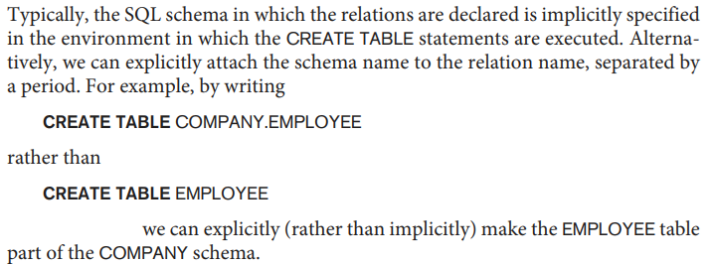
Figure 6.1 SQL CREATE TABLE data definition statements for defining the COMPANY schema from Figure 3.6.
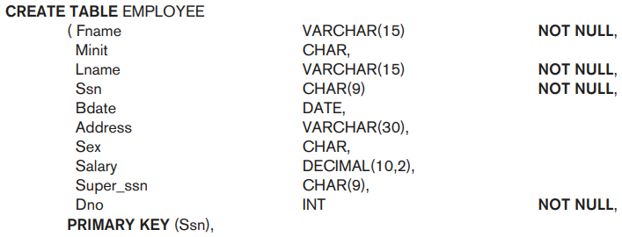
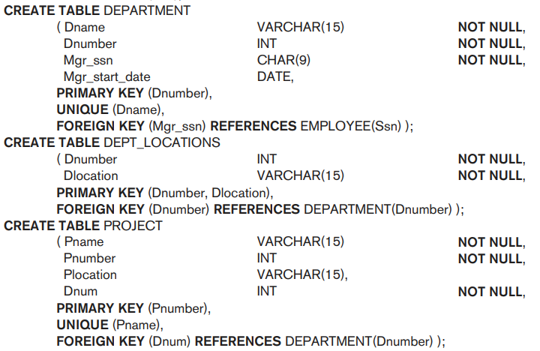
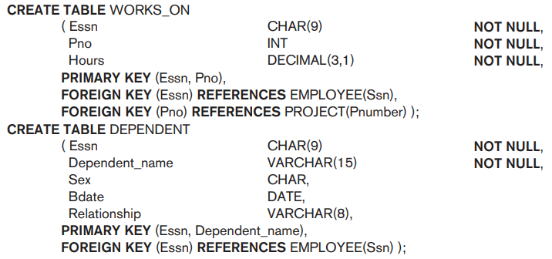
In SQL, the attributes in a base table are considered to be ordered in the sequence in which they are specified in the CREATE TABLE statement. However, rows (tuples) are not considered to be ordered within a table (relation).

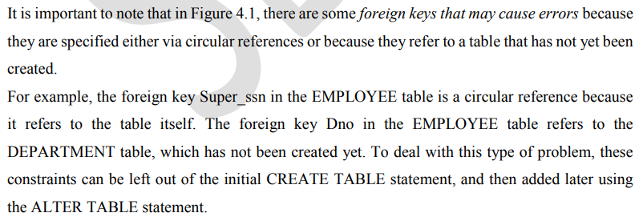
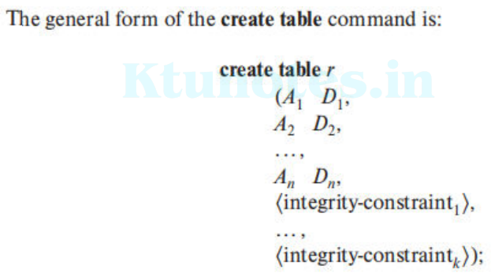
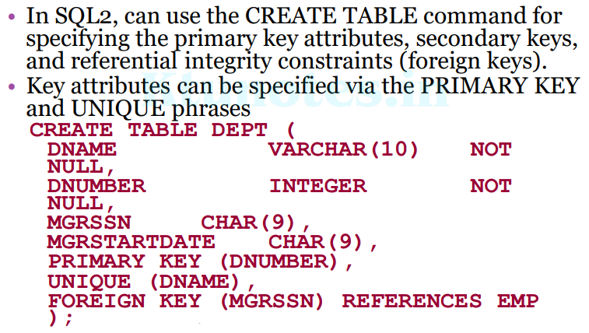
Attribute Data Types and Domains in SQL
The basic data types available for attributes include numeric, character string, bit string, Boolean, date, and time.
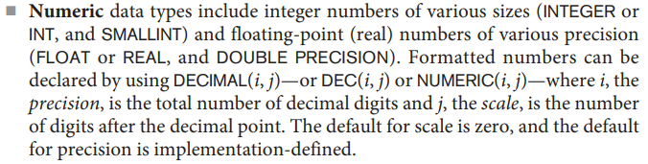
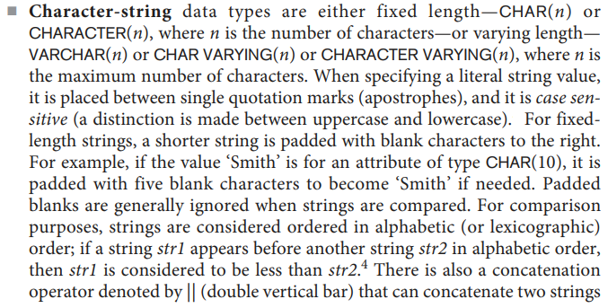
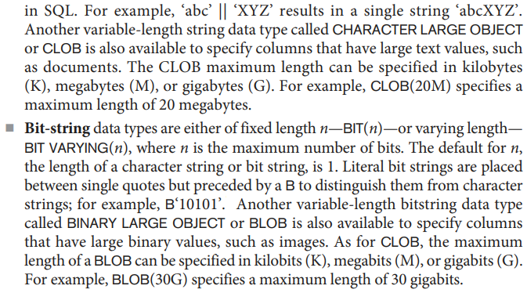
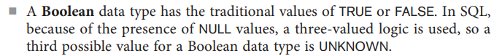
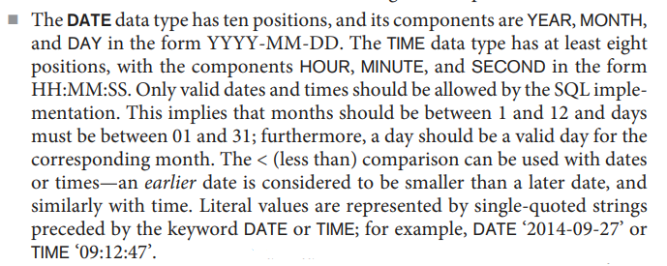
Some additional data types are also there:
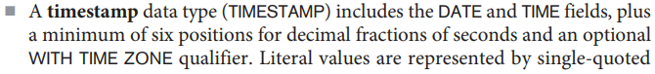
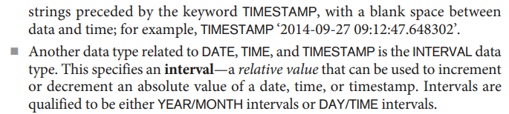
It is possible to specify the data type of each attribute as a domain of values, and the domain name can be used with the attribute specification.
For example, we can create a domain SSN_TYPE by the following statement:
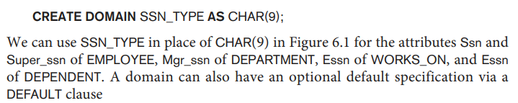
In SQL, there is also a CREATE TYPE command, which can be used to create user defined types or UDTs. These can then be used either as data types for attributes, or as the basis for creating tables.
Specifying Constraints in SQL
Specifying Attribute Constraints and Attribute Defaults
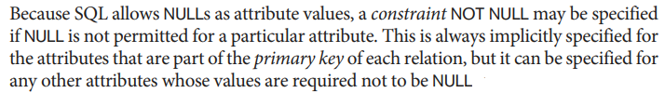
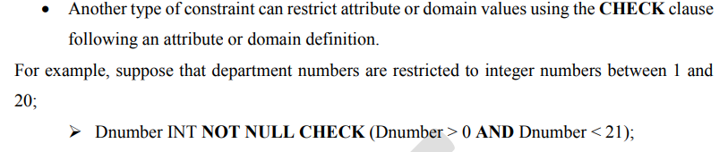
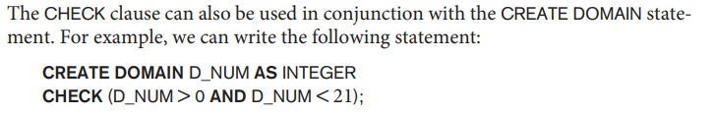
Specifying Key and Referential Integrity Constraints
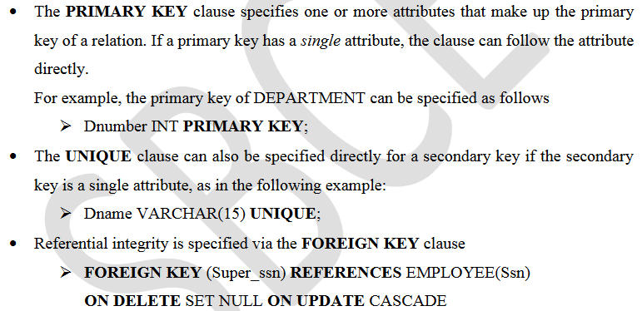
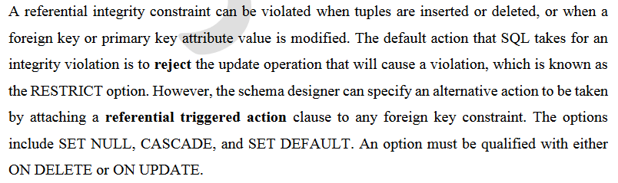
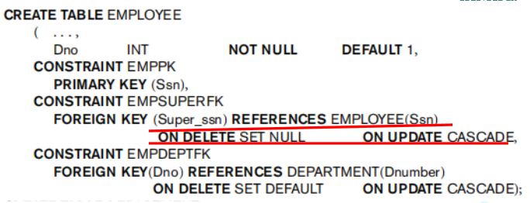
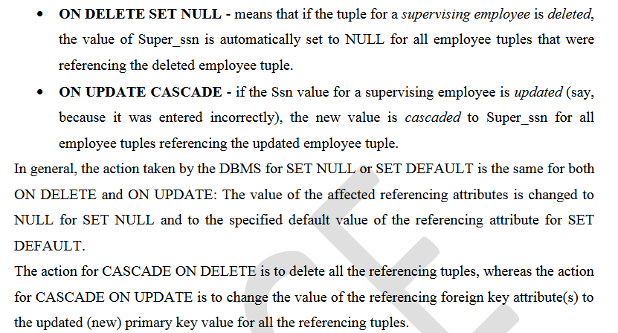
Giving Names to Constraints
- The names of all constraints within a particular schema must be unique.
- A constraint name is used to identify a particular constraint in case the constraint must be dropped later and replaced with another constraint.
- Giving names to constraints is optional.
- The keyword CONSTRAINT is used along with constraint name.
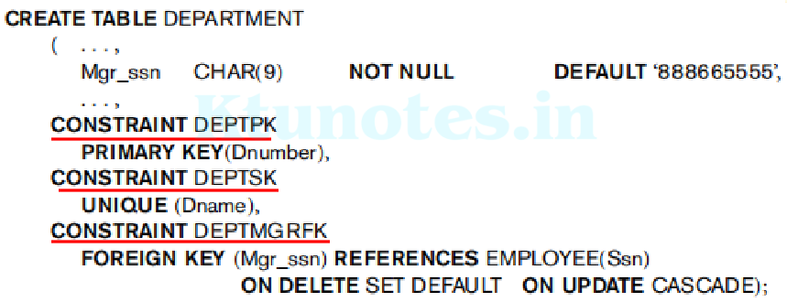
Specifying Constraints on Tuples Using CHECK
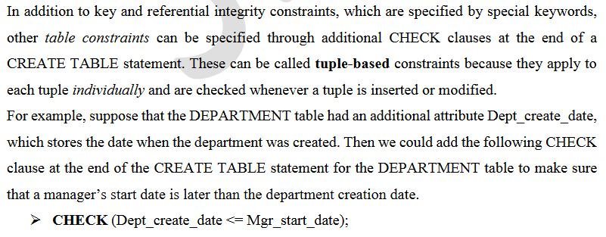
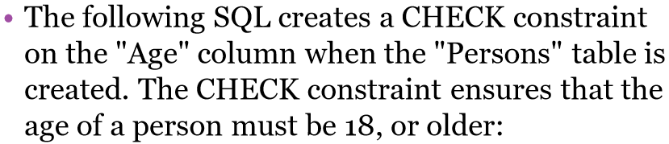
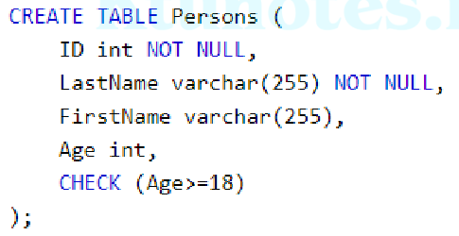
The DROP Command
- DROP is used to delete a whole database or just a table.
- The DROP statement destroys the objects like an existing database, table, index, or view.
- The SQL DROP TABLE statement is used to remove a table definition and all the data, indexes, triggers, constraints and permission specifications for that table.
- You should be very careful while using this command because once a table is deleted then all the information available in that table will also be lost forever.
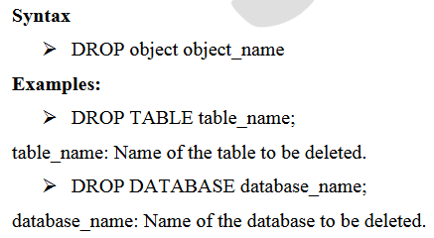
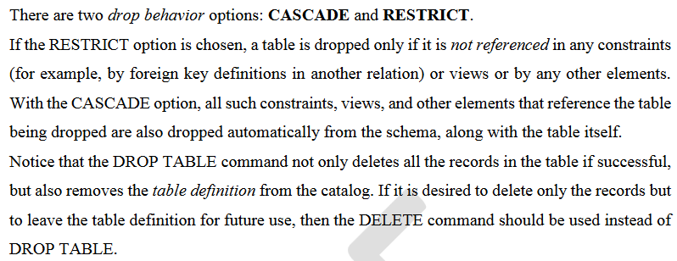
ALTER TABLE
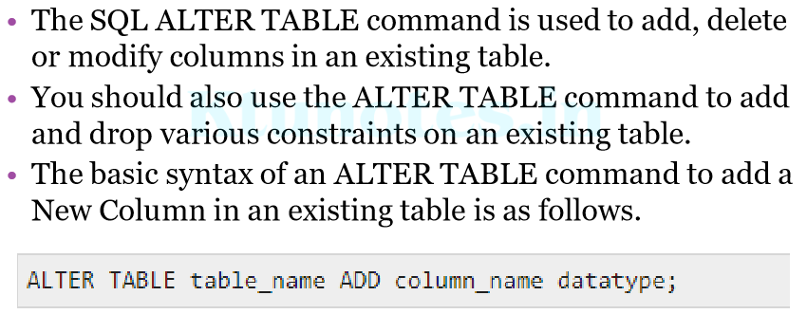
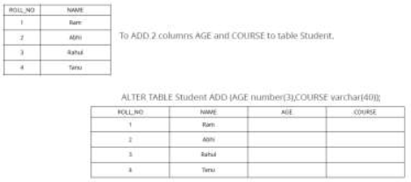
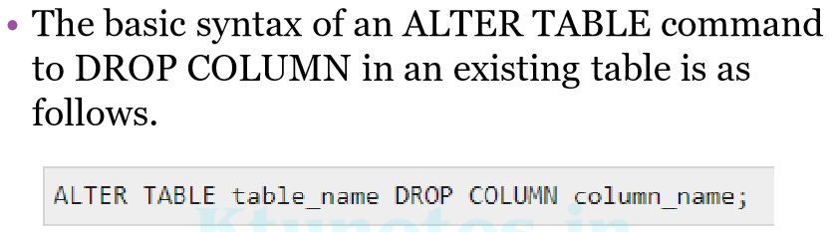
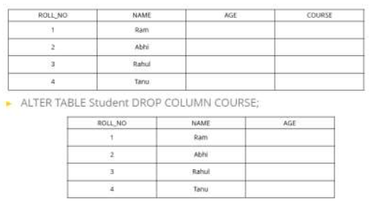
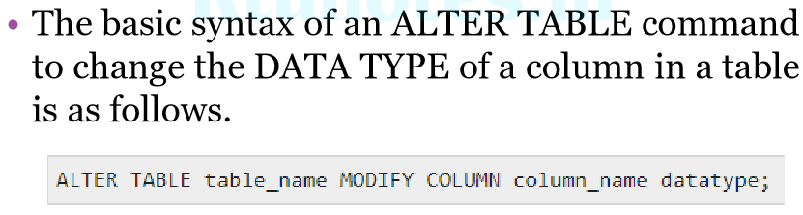
Example
➢ ALTER TABLE Student MODIFY COURSE varchar(20);
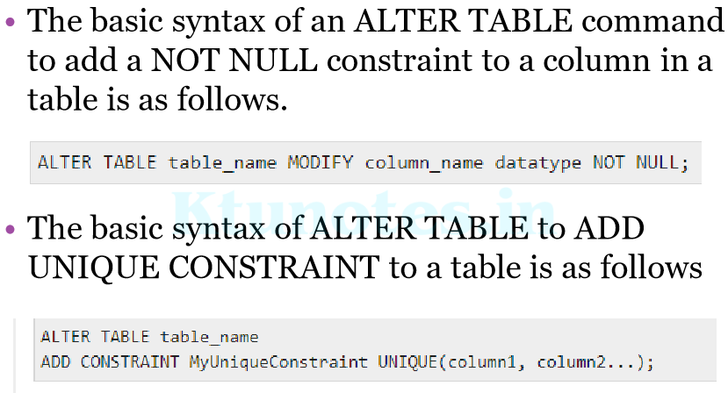
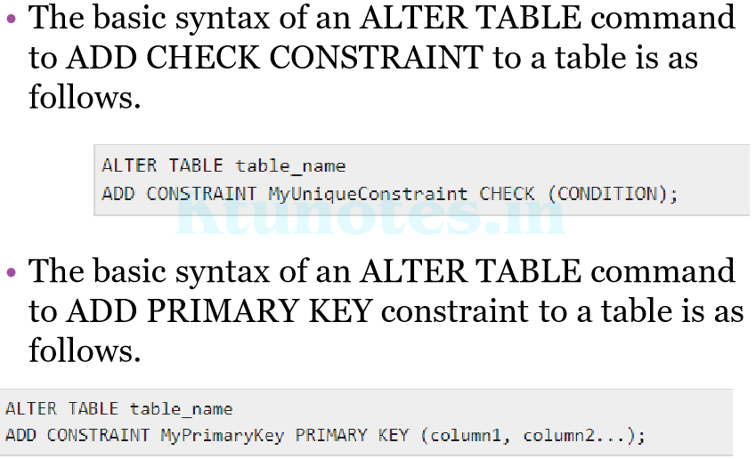
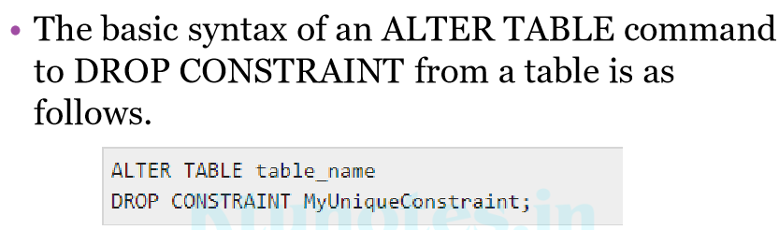
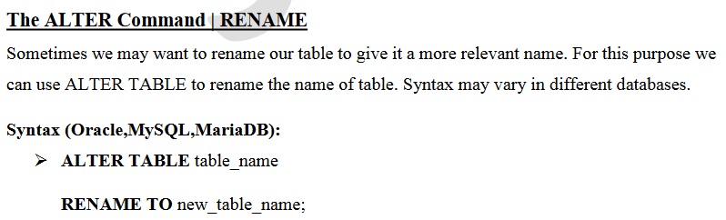
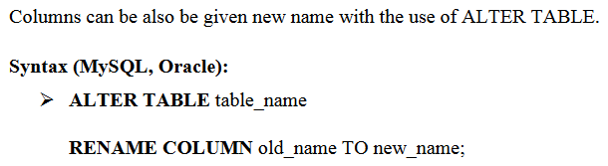
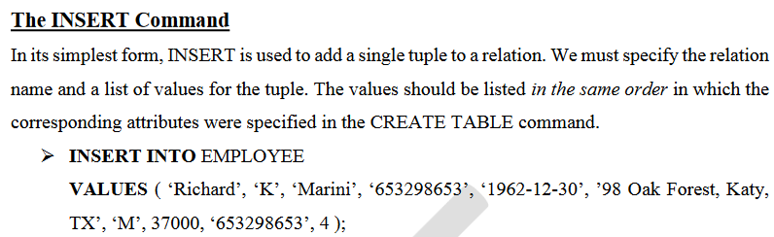
- A second form of the INSERT statement allows the user to specify explicit attribute names that correspond to the values provided in the INSERT command.
- This is useful if a relation has many attributes but only a few of those attributes are assigned values in the new tuple.
- However, the values must include all attributes with NOT NULL specification and no default value.
- Attributes with NULL allowed or DEFAULT values are the ones that can be left out.
- For example, to enter a tuple for a new EMPLOYEE for whom we know only the Fname, Lname, Dno, and Ssn attributes.
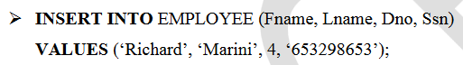
- Attributes not specified are set to their DEFAULT or to NULL, and the values are listed in the same order as the attributes are listed in the INSERT command itself.
- It is also possible to insert into a relation multiple tuples separated by commas in a single INSERT command.
- The attribute values forming each tuple are enclosed in parentheses.
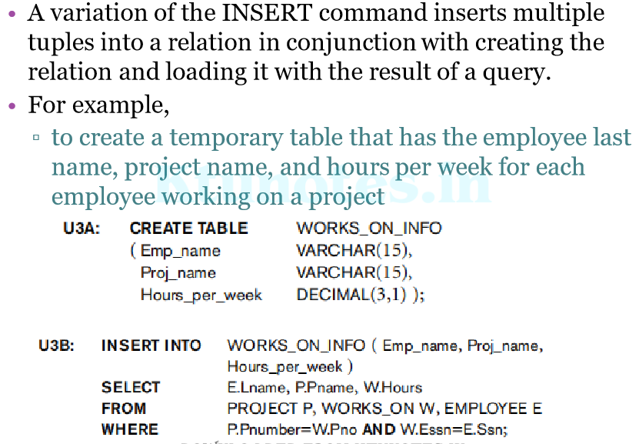
The DELETE Command
- The DELETE command removes tuples from a relation.
- It includes a WHERE clause, similar to that used in an SQL query, to select the tuples to be deleted.
- Tuples are explicitly deleted from only one table at a time.
- However, the deletion may propagate to tuples in other relations if referential triggered actions are specified in the referential integrity constraints of the DDL.
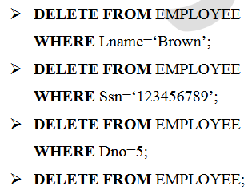
- Depending on the number of tuples selected by the condition in the WHERE clause, zero, one, or several tuples can be deleted by a single DELETE command.
- A missing WHERE clause specifies that all tuples in the relation are to be deleted; however, the table remains in the database as an empty table.
- We must use the DROP TABLE command to remove the table definition.
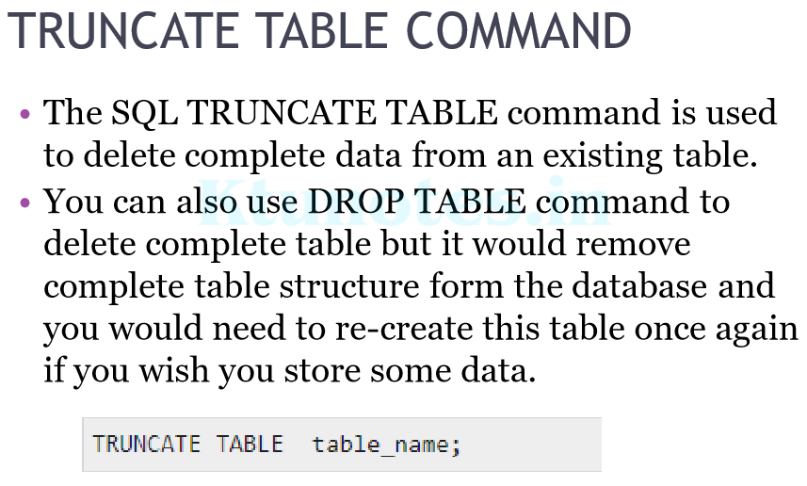
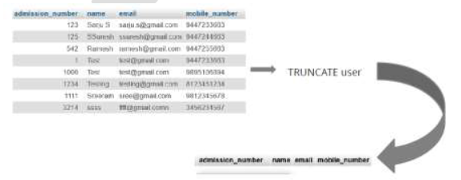
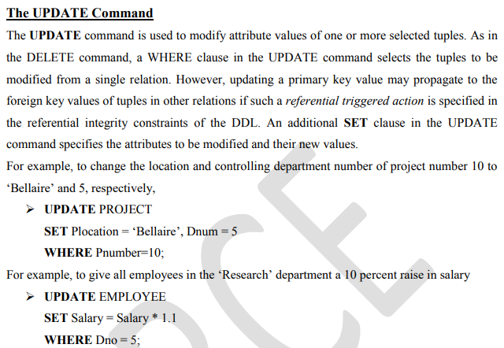
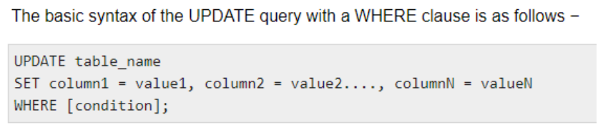
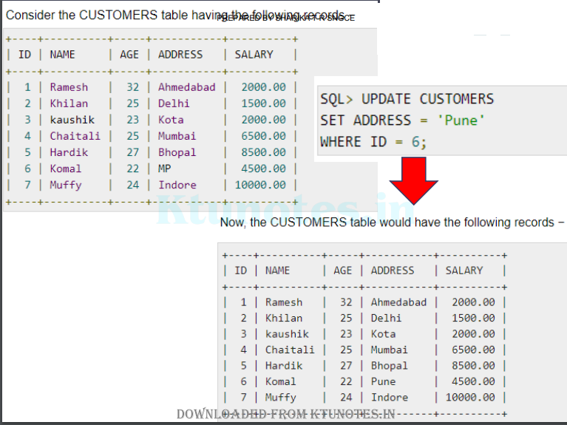
- It is also possible to specify NULL or DEFAULT as the new attribute value
- Each UPDATE command explicitly refers to a single relation only.
- To modify multiple relations, we must issue several UPDATE commands.

